THE OFFICIAL PUBLICATION OF ALOA ■ AN

f

N OF SECURITY PROFESSIONALS

June 2001

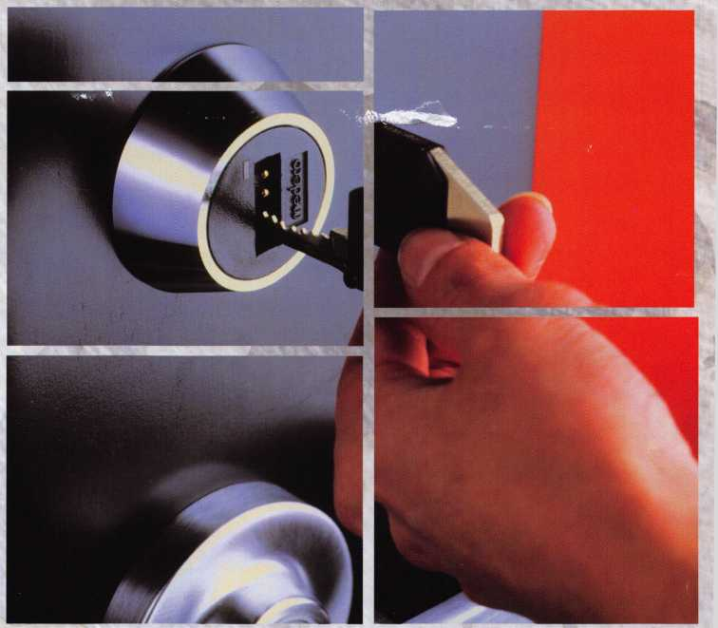

)F BOTH WORLDS

***High Security Innovations***

***EXPAND***

I _ _ * _

* A / to / LJ c>

Classroom Intruder:

A New Lock Function from Medeco

High Security Gold Mine:

Reviving an ISM X6

Schlage Primus:

High Security with an Edge

And More

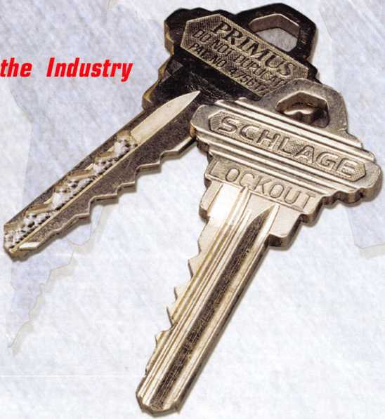

one.

do you know what to expect

when tomorrow arrives?

witness the



ALOA 2001

unexpected

july 15-22

at

baltimore

convention center.



**Members Ship for Less**

Choose Airborne Express...

...across any state... ) ( ...across the country... ) ( ...or around the world. )-^

Rely on Airborne Express for exceptional service,  
guaranteed delivery and the best possible rates!

* Guaranteed delivery for your peace of mind.
* Dedicated member support at 1-800-MEMBERS.
* Easy to use online package tracking.
* Additional discounts when using an  
  Airborne Express Drop Box.

|  |  |  |  |
| --- | --- | --- | --- |
| r |  |  |  |
| moose tne Best Value* | [Zone 2  1 (within 150 miles) | Zone 5  (600-1,000 miles) | Zone 8 ^  (1800+ miles) |
| ■ Airborne Express | $9.72 | $11.34 | $12.15 |
| 1 UPS | $12.25 | $14.50 | $15.75 |
| ^FedEx | $12.75 | $15.00 | $16.25 J |

Call 1-800-MEMBERS

It's easy to save! Choose from next morning, next afternoon, second day and international services. There are no minimum number of shipments, and no contracts required for these special rates.

**Get Your FREE Airborne Express Starter Kit**

Return this coupon for your free Starter Kit and special Airborne account.

ContactTitle

Company

Address (no PO Boxes) City

State.

Zip.

Phone.

Fax.

I am a member of

Associated Locksmiths of America

Email.

What will your average monthly shipments with Airborne be? 0 0-9 □ 10-19 0 20+ 0 125+

□ Tell me how I can save even more by pre-purchasing Flight-Ready3” letters and packs with no weight limits.

<£

**1-800-MEMBERS** \

(1-800-636-2377,8 am - 7 pm, ET) J



**1-888-461-4664**

(fax toll-free, 24 hours)

*0—*

Code: ALOAN5*Y107

**/IIRBORNE**

EXPRESS.

moabx-12/00 PR1000A

* Rates shown are for an 8 oz. overnight letter express and are subject to change. Airborne Express rates based on average shipping volume of 10 or more packages per month. Call for pricing if averaging less than 10 shipments monthly. Member rates are even lower when averaging 20 or more shipments per month.

Call 1-800-MEMBERS for this volume pricing.



June 2001

Volume 47, Issue 6



4

**President’s Journey**

By John Greenan, CML, CPS

10

Value Added

By Claire Cohen, CML



16

High Security Cover Feature: Access Control **The Best of Both Worlds**

Bringing EAC and pin tumbler locks together. Combining access control features with high security mechanics isn't exactly a cakewalk. They're just two different beasts, right? Wrong. Medeco takes you to the best of both worlds.

By Warren Schimizzi

20

**Traditional Locksmithing -**

Schlage Primus: High Security with an Edge

The trick to how to make it strong, simple and affordable. Each man­ufacturer faces this challenge in its own way. Schlage's approach is the Primus, and this is article is a must-read for anyone working with it, or considering this system.

By AJ. Hoffman, CML

Automotive:

**Replacing Door Clips on 87-95 Nissan Pathfinder and**

**ckups**

I nese vehicles have an outside lock control linkage that is readily  
serviceable on the lock end, but rather scary on the bottom end if you  
have not been in a position to become familiar with it.

By Bob Arhtur, RL



28

Institutional Locksmithing:

**Classroom Intruder: A New Lock Function from Medeco**

Students with vengeance on their minds stalk the hallways, ready to shoot anybody in their way. These events are much more rare than the media might suggest, but they do call attention to security lapses in the school environment. The focus of the institutional locksmith may be to start pointing out the shortcomings of the traditional class­room function hardware.

By Sal Dulcamara, CML

30

Safes

**High Security Gold Mine: Reviving an ISM X6**

Occasionally, someone will give you an old safe worth a lot of money restored, but how much will it cost you and do you have a customer who might want it? We were given just such a safe. It was an ISM TRTL30X6 in very sad shape.

By Greg Perry, CML, CPS

34

Catching up with Mul-T-Lock

Following last year's ASSA ABLOY AB purchase of Mul-T-Lock, company officials were looking for the marriage to enhace the visior and prosperity of Mul-T-Lock to provide the best high quality high security key control products to all of its customers.

**DEPARTMENTS**

2

Contents

4

President's Journey

8

Core

12

Applicants

15

Upcoming Events

38

Legislative Update

40

Classifieds

42

Associate Member Listing

44

Back Page

VISIT OUR WEB SITE AT:

[www.aloa.org](http://www.aloa.org)

June 2001

2 I ***Keynotes***

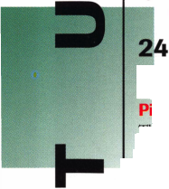

Editor

Technical Editor

Editorial Advisor

Art Director

Advertising Sales

Contributors

Jim DeSimone [editor@aloa.org](mailto:editor@aloa.org)

David Lowell, CML, CMST [david@aloa.org](mailto:david@aloa.org)

John D. Cannon, CML [jdcannon@worldnet.att.net](mailto:jdcannon@worldnet.att.net)

Lindsay Magers [lindsay@aloa.org](mailto:lindsay@aloa.org)

Susan Haverkamp 121 Davis Street Nacogdoches, Texas 75961 Phone: (936) 569-7172 VoiceMail: (208) 248-8893 e-mail: [adsales@aloa.org](mailto:adsales@aloa.org)

Jerome Andrews, CML Paul Chandler, CRL Claire Cohen, CML Brian Costley, CML, CMST Ray D'Adamo, CML Sal Dulcamaro, CML Billy Edwards, CML Dan Graffeo, CRL,CMST A.J. Hoffman, CML Jeff Nunberg, CML, CMST Mikey Oehlert, CPL, CPS Randy Simpson, CML Robert Stafford, CML Dave Thielen, CML Greg Perry, CML,CPS Tom Seroogy Charles Stephenson, CPS Dennis Watanabe, CML, CMST

|  |  |
| --- | --- |
| Executive Director | Charles W. Gibson, Jr., CAE [charlie@aloa.org](mailto:charlie@aloa.org) |
| Convention & Meetings Manager | Kelly Carr, CMP [kelly@aloa.org](mailto:kelly@aloa.org) |
| PRP/Education Manager | David Lowell, CML, CMST [david@aloa.org](mailto:david@aloa.org) |
| Operations/Membership Manager | Mary May [mary@aloa.org](mailto:mary@aloa.org) |
| Director of Information Technology | Randy McChristian [randy@aloa.org](mailto:randy@aloa.org) |
| Government Affairs Manager/ Chapters & Regional Associations Liaison | Tim McMullen [tim@aloa.org](mailto:tim@aloa.org) |
| Comptroller | Kathy J. Romo |
| Network Specialist | Greg Jackson |
| Membership Coordinator | Shelly Jett |
| Convention & Meetings Assistant | Karen Lyons, [Karen@aloa.org](mailto:Karen@aloa.org) |
| PRP/Education Coordinator | Ashley Manson |
| Accounting Coordinator | Kathy Stokes |
| Mail Room Coordinator | Humberto Cerda |
| Receptionist | Alin Valdez |

Additional contact  
information for the  
ALOA Board and most  
Keynotes authors is  
available through  
“Locksmith Search'”  
on the ALOA Web site- [www.aioa.org](http://www.aioa.org) or by  
contacting the ALOA office  
at 3003 Live Oak Street;  
Dallas, TX 75204;  
[800)532-2562;

FAX [214)827-1810;  
e-mail [aloa@aloa.org](mailto:aloa@aloa.org).



Mission Statement: The Associated Locksmiths of America, Inc. is dedicated to enhancing the professionalism, education and ethics among locksmiths and those in related sectors of the physical security industry. With approximately 10,000 members in the United States, Canada and the freeworld, ALOA is poised to help members obtain the knowledge, the strength, and the confidence to perform their role in the physical security field with pride and dignity. But it is only through active involvement and participation that ALOA can fully achieve its potential-and can help members to achieve theirs.

Policies: Keynotes® is the official publication of the Associated Locksmiths of America, Inc. (ALOA). Keynoted acts as a moderator without approving, disapproving, or guaranteeing the validity or accuracy of any data, claim, or opinion appearing under a byline or obtained or quoted from an acknowledged source. The opinions expressed by the authors do not necessarily reflect the official views of ALOA. Also, appearance of advertisements and new products or service information does not constitute an endorsement of products or services featured by the Association. The Association does not accept responsibility for the inaccuracy of any data, claim, or opinion appearing in this publication, due to typographical errors on the part of the authors, Association staff or its agents. Editor’s Note: This publication is designed to provide accurate and authoritative information in regard to the subject matter covered. It is provided and disseminated with the understanding that the publisher is not engaged in rendering legal or other professional services. If legal advice and other expert assistance is required, the services of a competent professional should be sought.

Authors’ Payment: Payment for eligible submissions to Keynotes will be based on the following criteria: topic, time spent and past contributions. Authors who regularly submit to Keynotes are generally paid a higher rate. The latter is especially true of authors who write to fit specific editorial needs and submit said copy by Keynotes deadlines. As a general guideline: Average payment for a 750 word, business or light’ technical article would be $200. Payment for a 1500 word article involving significantly higher time and research efforts would be $400.

Payment will not be offered for articles submitted by ALOA employees or members of the ALOA Board of Directors (unless material is of a technical nature), nor for articles submitted by a company that promote that company’s products or services. ALOA reserves the right not to pay for articles submitted by an individuals) that promote a particular company's products or services.

Disclaimer: The Associated Locksmiths of America, Inc., (ALOA), reserves the right to refuse any article for any reason. Additionally, ALOA reserves the right to edit, amend or modify any article submitted for publication in order to preserve technical accuracy, clarity, fairness or grammatical correctness. ALOA will make the best efforts to notify the author of any changes. The extent of ALOA’s liability for any article or information contained therein will be a notice of correction or retraction in the next possible issue.

Keynoted (ISSN 0277 0792) is published monthly except for the combined June/July issue by The Associated Locksmiths of America, Inc., 3003 Live Oak St., Dallas, TX 75204-6186. Telephone: (214) 827-1701; FAX (214) 827-1810; e-mail [aloa@aloa.org](mailto:aloa@aloa.org). Subscription rates for members-$15.00 per year. Second class postage paid at Dallas, Texas. POSTMASTER: Send address changes to: Keynotes, 3003 Live Oak St., Dallas, TX 75204-6186. © Copyright 1999, All rights reserved. No part of the contents may be reproduced or reprinted in any form without prior written permission of the publisher.

President

John J. Greenan, CML, CPS (773) 486-2030 [fsl.john@mindspring.com](mailto:fsl.john@mindspring.com)

Secretary

John D. Cannon, CML (703) 960-6413 [jdcannon@worldnet.att.net](mailto:jdcannon@worldnet.att.net) Directors, Northeast John C. Magee, III (856) 845-3434 Peter Sarailian, CRL (201) 947-6291 [psarailian@yahoo.com](mailto:psarailian@yahoo.com) William L. Young, CML (610) 647-5042 Directors, Southeast Thomas W. Tate (850) 476-4211 Donald E. Rule, CML

1. 324-2658 [rulecml@ebicom.net](mailto:rulecml@ebicom.net) Directors, North Central Mark E. Blum, CML, CPS (517) 482-5809 [mblum@arq.net](mailto:mblum@arq.net)

Tom Ripp, CRL (608) 262-3831 Director, South Central Randy L. Simpson, CML (713) 780-7026 Directors, Southwest Gordon R. Racine, CML (719) 384-4707 [aloaswdir@excite.com](mailto:aloaswdir@excite.com) John A. Ilk CRL

1. 420-2174 [getreil@yahoo.com](mailto:getreil@yahoo.com) Director, Northwest Scott L. Henke, CRL, CPS (907) 248-3785 [action@alaska.net](mailto:action@alaska.net)

Director, Associate Members

David F. Matthies

(727) 541-5536

dmatthies@southernlockcom

Trustees

Dallas Brooks

(334) 826-8990

David M. Lowell, CML, CMST

(800) 532-2562

Brack H. Camp, CML

(770) 455-6244

Edwin Toepfer, RL

(416) 225-5589

Past Presidents

1997-1999 Dallas C. Brooks 1995-1997 David Lowell, CML, CMST 1993-1995 BreckCamp, CML 1991-1993 Henry Printz, CML 1989-1991 Evelyn Wersonick CML, CPS 1987-1989 Leonard Passarello, CPL 1985-1987 Joe Jackman, CML 1983-1985 Stanley Haney, CPL 1981-1983 Louis LaGreco, CPL 1979-1981 John Kerr, RL 1977-1979 Clifford Cox, CML 1974-1977 Charles Hetherington 1972-1974 Gene Laughridge 1970-1972 William Dutcher, RL 1968-1970 Constant Maffey, RL 1966-1968 Harold Edelstein, RL 1964-1966 William Meacham 1962-1964 Robert Rackliffe, CPL 1960-1962 Edwin Toepfer, RL 1956-1960 Ernest Johannesen

June 2001

***Keynotes***

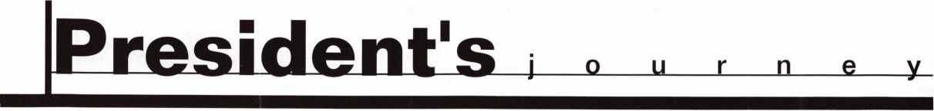

PRESIDENT’S JOURNEY

You are in the business of providing security and piece of mind. You are in the busi­ness of selling your knowledge and expertise. You are in the business of locksmithing to make money as a professional. Your customer came to you seeking your advice as a professional locksmith. Your expert recommendations for quality high security hardware that provides them with real security, reinforces the confidence that they have placed in you. By doing this you can charge accordingly and provide the expert­ise that the customer expects when seeking a professional locksmith. That’s thinking like a business person.

ALOA wants you to succeed not only as a locksmith, but as a business person as well. That is why we offer more education every year, including the 75 full-day classes, 38 half-day classes and 6 seminars at ALOA 2001 in Baltimore, Maryland. But don’t just take the educational classes on how to be a better locksmith, take some of the busi­ness classes that will teach you how to be a better business person. These include:

* From Locksmith to Security Professional
* Basic Locksmith Marketing
* Increase Your Revenues by 25% this year
* Advanced Shop Management
* eMarketing 2001
* Providing Total Customer Care
* Making Money Selling Cash/Handling Safes
* Selling Key Control Systems
* Cash Management
* Financial Management for Locksmiths (2 day class). This course is sponsored by the ALOA Scholarship Foundation. Students who complete this course as part of a Seven or Five-Day Package will receive a $200 rebate which will be mailed to the payer after the close of convention.

It’s up to you to take the first step, and ALOA offers you wonderful opportunities to do so. Take one business class at the ALOA convention, that’s all I’m asking. It will be the best investment you’ll ever make.

John J. Greenan, CML, CPS

June 2001

4 | ***Keynotes***



***Visit our Website on  
www. stamcctv. com***

**THE COMPLETE**

**CCTV PROGRAM ON CD-ROM  
FOR STAFF TRAINING AND**

**PRODUCTIVITY ENHANCEMENT**

STAM Insight has been  
developed to enhance CCTV  
skills and productivity with  
many different uses.

t# Productivity

I# System Drawing h§ Estimation Ml CCTV Training li CCTV Reference hi Sales/Demo I# System Design t# Staff Evaluation

14 hours

CCTV Content

CCTV Calculators

Demonstration Tool

Estimation

Drawing

Internet Enabled

Knowledge Assessment

**INFOMATE WORKMATE ULTIMATE**

**Sold in Over 50 Countr**

Distributed by:



3003 Live Oak Street  
Dallas,Texas 75204

Name:

Job Title:

Organization: Address:

.Zip/Postcode, .e-mail

Fax: ( )

COPYRIGHT © 1996 Security Training and Marketing Pty Ltd. All rights reserved ACN 057 006 541

Country

Tel: ( )

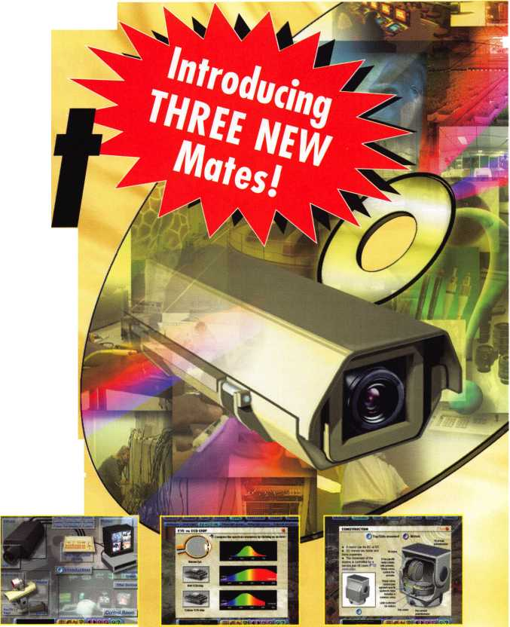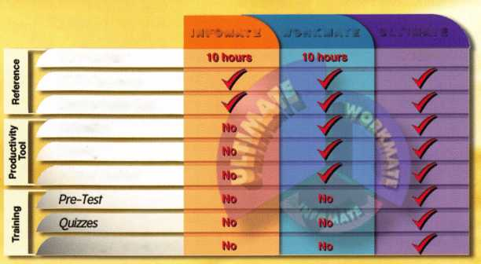

Ak Anchorage

Jim Pennington SPONSOR: Scott Henke

CA San Francisco

Trudee A Gardner SPONSOR: Katy Lawson

CO Evans

Robert L Dorn

SPONSOR: Raymond D'Adamo

DE

New Castle  
David J Healey  
SPONSOR: William Young

Wilmington Samuel T Brown

FL Indialantic

Michael J Ottomanelli SPONSOR: Michael Dunlevy Palm Bay Vincent F Lerose SPONSOR: Michael Dunlevy Pompano Beach Jason J Massaro SPONSOR: Robert Carroll Terry Barber

SPONSOR: Robert Carroll

GA Bethlehem

Paul M Amason SPONSOR: Breck Camp Smyrna Harry E Hagan

HI Honolulu

Justin A Ochida Melvin T Shitagi

IL Chicago

Jorge O Martinez Des Plaines Devin F Wascher loliet

Terry L Gebhardt SPONSOR: William Beranek

KS Overland Park

Shawn W Whitebread SPONSOR: Chester Whitebread

KY Louisville

Ben Weas

MD Glen Burnie Robbie Buss SPONSOR: Eric Roes



Keynotes

June 2001

ME Gorham

Robert F Wanser SPONSOR: Thomas Moulin Springvale

Patrick A Robichaud SPONSOR: Richard Lamb

Ml Detroit

Lorenzo White SPONSOR: Dwayne Crenshaw Grand Ledge Eric Andrews SPONSOR: Mark Blum Grand Rapids Christopher Deblaey SPONSOR: Thomas Ziemer

MN Bemidji

Mark A Schmitt

MO lefferson City

Sharon S McFerron SPONSOR: P Kevin Hunton Michael P McFerron SPONSOR: P Kevin Hunton Linn

Brandon M Bock SPONSOR: P Kevin Hunton Goldsboro Wayne Gow

SPONSOR: Downie Dowless Greenville William E Blecha Jr. SPONSOR: William Young

NJ Creamridge

James L Kuzianik SPONSOR: William Young Long Branch Christopher Tanzi Matthew Marhen West Orange Ely Peleg

SPONSOR: Peter Sarailian

NV Las Vegas

David D Kerr

NY Bronx

Edwin Lugo Delmar Scott West

SPONSOR: Peter Sarailian

Maspeth

James G Oliveri

Victor D'Aquino

Craig P Wessel

New York

Peter Argese

SPONSOR: William Young Joel A Solomon

SPONSOR: Peter Sarailian Joseph R De Arce SPONSOR: Peter Sarailian Plainview Jonathan S Siegel Queens Village Michael Wolfson SPONSOR: Gary Bieniewicz Staten Island Thomas E King SPONSOR: William Young

OH Lancaster

Hillard Kloda

PA Ambridge

Patrick L Noling SPONSOR: Michael Kugg Annville PaulE Snyder SPONSOR: Mark Reed Pennsburg Randy J Loose SPONSOR: Peter Sarailian

TX Allen

Mike D Angel CRL

Rockwall

Tim J Culmo CRL

VA Ft. Lee

Brian Cameron SPONSOR: Michael Groves Roanoke

Charles D Stracke Virginia Beach Robert Chartrand

Wl Madison

Jeffrey E. Smith SPONSOR: Tom Ripp

Canada

ON Gloucester

Terry G Duncan

Ireland

Waterford TonyJ Fitzpatrick

Japan Koufu City Yamanashi

Shogo Shimizu SPONSOR: Yuriko Yanai Tomiaka-citv.Futaba Gun Masaki Hashimoto SPONSOR: Takashi Kuwana

Korea Hanam-Si Kvung Gi Do Sung Hwan Hong SPONSOR: ManSSeo

Kwok-kei Leung

Toshihiro Asano

Henry W Raymond

Yuriko Yanai

Stewart J Levine CML

Mary S Ohmit CPL

Charles C Robertson CML

Jack Hobin CPL

William B Neff CML

Salvatore J Dulcamaro CML

Myeong-Rae Cho

Dana L Barnum CM

Barry K Leas CRL

Danny W Rudd CPL

Larry A Warnick CML

C Allan Halverson

Jeanne G Lodge CML

Lawrence F Smith Jr, CML

Anthony J Ramunno CML, CPS

James M Watt CML, CPS

Jeffrey S Nunberg CML, CMS

J Thomas Hood CML

Jim Williams CR

Marian M Swann CRL

James H Glazier Sr, CML

Robert F Carroll CPL

Robert H Stafford CPL

William Lee

John C Elliott Jr, CML

Jerome L Cohen CML

Peter K Gauthier CPL, CPS

Elvis D Hammerschmidt CPL

Robert D DeWeese CML

Man S Seo

James J Cawby CML, CPS Eugene R Altobella Sr Michael B Groves John L Shandy CML Hans Mejlshede CML John S Dorsey CML D Michael Lee Sr, CPL Robert W Duman Sr, CML Philip A Rovenolt CPL James E Fowler Sr, CML David C Harris CML Michael Robinson CRL Peter R Hall

Thomas G Vandersteen CML, CPS

William P Grant CRL

Keizo Takahashi CRL

Walter W Lascar RL

Evelyn V Wersonick CML, CPS

Joseph P Ferrero CML

Gary F Teams CPL

Michael E Jordan Jr, CML

Brian J Reetz

Robert C Rodocker CRL

William J McElheney CML

Jon B Griswold CML

Russell P Fuller CRL

Daniel L Landry Jr

James L Hancock CRL

James E Gruber CRL

Joseph W Whitaker CPL

202

109

100

68

66

66

65

51

45

40

38

35

35

31

31

31

30

26

26

26

26

26

26

25

25

25

25

25

24

23

23

23

23

23

21

21

21

19

19

19

19

19

19

18

18

18

17

17

17

17

16

16

16

16

16

16

15

15

15

15

15

15

14

14

Brightest

And The

Best.

Joseph C Fuller CML, CMST 13

Leonard J Passarello CPL 13

Frank D Hartung CML 13

Paul M Souber 13

Donald H Shiles RL 13

Richard C Sievers 13

Joe J Lee CRL 13

Ernest W Wright 12

Rolando Bouza 12

Raymond C Lusk CML 12

John F Engel CRL 12

Eric F Veal 12

Basil W Shannon CPL 11

Calvin G Harris CML 11

Herbert C Dusenberry CML, CPS 11 Timothy K Chow 11

Dale L Knowles CPL 11

Thomas J Demont CML, AHC 10

Alvin N Minor 10

Gene Eldridge CPL 10

Ronald P Riggins CML 10

Lester S Brodsky 10

Larry L Votaw CML 10

Thomas R Smith CPL 10

William T Straub CML 10

Richard T Johnson CPL 10

Dale V Crosby CPL 10

James V Hawley CRL 10

Eugene R Altobella Jr 10

James Bright 10

How can I join the President's Club?

You can earn a membership in this prestigious club by recruiting just 10 new members for ALOA.

*Any ALOA member may participate.

What do I get?

When you recruit 10 members, you receive a handsome blue blazer with a President's Club crest. For each additional five members you recruit, you receive a lapel pin with gold-filled numbers, indicating, your recruit­ing successes.

You also get the satisifaction of knowing that you are helping your association, helping your industry grow, and you are helping fellow locksmiths achieve success.

How do I get started?

Contact the ALOA office for a supply of applications [8001 532-ALOA or FAX [214] 827-1810. One President's Club credit is awarded for each new applicant. Credit is awarded only after the membership application is approved. However, the credit will apply for the period in which the application is received. Failure to identify yourself as the sponsor on the application form at the time it is submitted to ALOA for processing will forfeit any credit.

*ALOA Board of Directors not eligible for membership in the President's Club

June 2001

Keynotes



June

CORE

CONVENTION NEWS:

The show is almost upon us, and it's looking to be among our finest ALOA shows. Baltimore is a town rich in locksmithing tradi­tion, and many of the foremost locksmiths in the industry live and work on America's East Coast. The weather should be fantastic, and the harbor area where the convention is being held is probably the easiest downtown area in the country to explore on foot. The education offered at the convention this year is absolutely unmatched anywhere in our industry, and the exhibitors you will meet will show you new products the likes of which you have never seen. It's hard on locksmiths who miss shows of this magnitude because of all it can mean to the growth of your busi­ness. Register today for the show that will pay off for a lifetime! Call 800/532-ALOA (2562) to register for our July convention in Baltimore.

**MAILBOX:**

Great job on the March issue! Schlage Everest, llco 4000, Gardlock articles were very informative and I look forward to more of the same.

Richard Wolfe #29217

**Editor's Note:** Thanks for noticing,

Richard. That was our first issue with the five categories of articles in each issue. Keep your eyes peeled on Keynotes for guaran­teed feature articles in every issue on the fol­lowing major categories: Access Control, Automotive, Institutional, Safes and Traditional locksmithing. It's our way of say­ing thanks to you, the members who make ALOA what it is.

CORRECTION

In the May 2001 issue of Keynotes, the arti­cle "Bypassing the Anti-Theft Ring on the G.M. MATS Column" (pages 22-25), a proof­ing error resulted in some inaccurate techni­cal information. The first paragraph on page 24 should read:

"Depress the pin and with your other hand, turn the column shaft until the openings for the ring screws are aligned. Loosen the two

screws on the anti-theft ring"

Go back to the top end of the column, and seat yourself as if you were getting ready to drive the vehicle. Looking down upon the column, you will notice and opening in the anti-theft ring in the upper left, or 11 o’ clock position. Using a hook tool, or an ice pick bent about 1/2 inch on the end, place the hook through this opening facing to the left. By fishing around a little, you can find the locking pin where it protrudes through one of the grooves on the locking plate. Work the tool around until you can depress this locking pin. You will be able to feel spring tension pushing the pin up. When you feel the spring pushing against you, you will know you are on the top of this locking pin. **Depress the pin, and with your other hand, turn screws on the anti-theft ring.** (These screws DO NOT COME OUT.) The screws are designed to stay in the ring. Once the screws have been completely loosened, the anti-theft ring can be lifted off. Since the column has been disconnected from the lower shaft, the column shaft will turn easily with your thumb and fingers.

IN MEIMIORT

William H. "Loc Doc" Vaught, a long-time ALOA member from Morristown, Tenn., recently passed away at the age of 74. Vaught was born in West Virginia, but he grew up in Kentucky. He moved to Tennessee in the mid 1980s to work with his father in Vaught's Locksmith, which has now been passed on to another Vaught, William's son Jeffrey. He graduated from the University of Tennessee before serving in World War II as a criminal investigator and in the Korean War as company commander of a military police company.

AAA Unlocks 4,305,000 Vehicles in 2000

Here's some good news with gas prices skyrocketing...

AAA, the leading provider of roadside assis­tance to North American motorists, respond­ed to 28.7 million calls for emergency road service in 2000 - an increase of approxi­mately 100,000 calls from the previous year. The motoring and travel organization, which added more than one million new members

during the same time period, said the mod erate increase in road service call volume reflects last year's healthy economy anc motorists' willingness to spend money or preventative maintenance.

"Road service call volume could increase ir the coming year," warned Marshall L. Doney vice president, AAA Automotive Services, "i consumers begin to defer new vehicle pur chases, or mistakenly delay needed mainte nance in reaction to high fuel costs or othei economic uncertainty."

AAA's advice to consumers concerned abou the costs of automobile ownership is to care fully maintain their current vehicles to ensure trouble-free operation and avoid needlessly high repair bills.

"AAA independently inspects and approves nearly 7,000 automotive repair businesses ■ including new car dealerships and independ­ent shops - as part of its Approved Autc Repair program," Doney said. "AAA mem­bers and other motorists are encouraged tc patronize these businesses when seekinc reliable assistance with their vehicle service needs." The locations of AAA Approved Autc Repair shops are available on AAA Clut Web sites ([www.aaa.com](http://www.aaa.com)), and are available from AAA club offices.

Fewer than half of the road service calls received by AAA in 2000 - 44 percent - resulted in the vehicle being towed for serv­ice. The majority of the stranded motorists were able to return to the road with the motoi club's assistance.

Motorists who were unable to start their vehi­cles -- usually because of battery failure - accounted for 20 percent of the calls. These vehicles typically required a battery boost oi jump-start.

Other reasons AAA members required emer­gency assistance included lockouts, 15 per­cent; flat tires, 12 percent; extrication anc winching, 1 percent; and out of fuel, 1 per­cent. Miscellaneous calls were 7 percent oi volume.

AAA provides emergency assistance tc members through a network of elub-ownee fleets and more than 13,000 independenl service providers who operate 42,000 serv­ice vehicles -- the largest such fleet in Nortli America.

As North America's largest motoring anc leisure travel organization, AAA provides its 44 million members with travel, insurance, financial and automotive-related services. Since its founding in 1902, AAA has been a leader and advocate for the safety and secu­rity of all travelers.

8

***Keynotes***

June 2001

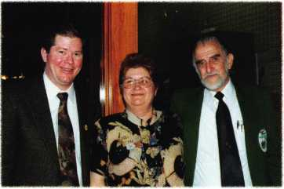

**CHECKING IN WITH CFLA**

The Central Florida Locksmiths Association recently installed new officers, and none other than ALOA President and consummate travellin' man John Greenan was on hand to install the new officers. John had some upbeat words about the state of the industry in his guest speaker address, then moved onto to do the honors as the new officers took the oath from him.

"We were so proud and honored to have John attend our benefit," said Janet Boyer, CRL, president of CFLA. Soon after, the fearless Mr. Greenan hit the open road again, this time to our own SafeTech convention up in balmy St. Louis. Soon enough, it was over the pond to Copenhagen, Germany, where the European Locksmith Federation (ELF) held their nation­al show. John represented the Yanks well, and a good time was had by all.



PRP

ALOA would like to congratulate the following individ­uals who have recently achieved PRP designations:

**CRL**

Mike Angel -- Allen, TX

Dale Bowman - Shawnsville, VA

Show up at the Show, Raffle Ticket in Hand, and You Could Drive Home in a Brand New Van!

T

he ALOA Scholarship Foundation will once again  
be raffling a brand new van at this year's ALOA

Convention and Security in Baltimore, MD, July 15-22.  
Every adult registrant who attends the show will be  
given one raffle tickets. Additional tickets will be sold  
by the Foundation in the vicinity of the ALOA booth on  
the show floor. Exhibitors may buy raffle tickets to give  
to attendees at their booths. They may be giving tick-  
ets away through drawings, to preferred customers or  
as part of a sales promotion. The van drawing will be  
held on the show floor during the final hour of the last  
day of the Security Expo (Sunday, July 21, 2001).

“Weighs” in BIG!

Enjoy the new technology from ABUS!  
Using the 83 Series Pinning Window™ Cylinder!

Unique

“Tear Drop”

Design

* Yale 8®
* Kwikset
* Schlage C
* Schlage C-L
* Corbin®
* Sargent®
* Arrow®
* Russwin®
* Weiser- Falcon
* Z-Bar®

**(ABUS)**

Ni 8 3/55 HARDENED

**NEW**

OLDER

Order the NEW “83/55” in any keyway from

your distributor! Receive a FREE ABUS ($7.99)

Trigger Lock for each # 83/55 ordered! That’S a 55% Savings!

HURRY while supplies last! Promotion ends - June 30, 2001

For ordering information:

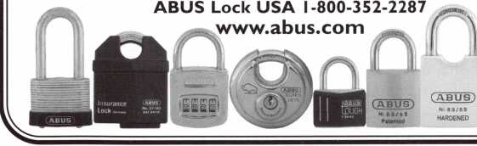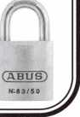

June 2001

Keynotes

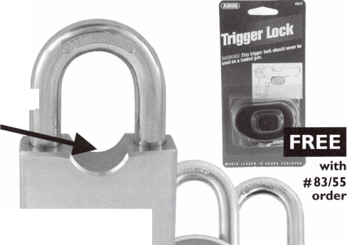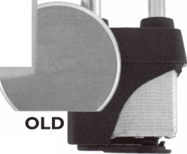

Take a look at today's "downsized" or "rightsized" work environment (or more realistically defined as "job cuts"). Our present workplace makes it imperative for employees to do all they can do to make themselves as valuable to their employer as possible. This holds true in the security industry or most any other industry.

The reason for improving ourselves as workers numbers in the thousands-actually the hundreds of thousands. Reading the daily paper or watching the news on TV each day details stories of companies who are reducing the size of their workforce.

Workers find themselves faced with a confusing challenge. Growing up, they were presented with a job environment where a worker stayed at the same company for decades with frequent pay raises, job promotions, training classes, and a chance to move up the company business ladder.

Technology has changed the rules! Business moves faster, incorporating new methods and technologies con­stantly. For the security professional, computers, advanced software, electronic products, and more sophis­ticated equipment has changed our industry.

All too often people are focused on individual, personal

goals of salary and benefits. They fail to recognize that

their company is in need of "value added" employees.

Value-added employees:

require little supervision

have multiple job-related skills

ability to teach co-workers

offers constructive ideas

show ambition and creativity

Moving forward can be a challenge. Our ever-changing pace of the workplace can create some legitimate obsta­cles toward learning. Perhaps the company has reduced the number of classes that will be corporate-sponsored, or the number of product seminars that they will host. A workplace in transition requires you to sometimes learn on your own.

And, sometimes people can be their own worse enemy as well. People often believe they must try harder. Sometimes, that's not the case. It comes in trying some different or working smarter.

101

***Keynotes***

June 2001

Adopting a commercial mentality is one way to approach becoming a more valuable employee. Think of your boss and your co-workers as customers. When you look at them that way, you'll come up with the smartest, most direct way to deal with their various needs and juggle the various demands on your time.

You might feel like you're on your own when attempting to increase your knowledge and exhibit your importance to your company. But take a closer look around your company, your co-workers, your suppliers, your local associations, and ALOA, to see many learning opportunities. Here are people (resources) who can help your career at some point in the future.

Don't rely on personal "likeability" as the key reason others will want you around even if your company is cutting jobs. Know your job. Know other people's jobs. Competence will most likely be foremost in management's decision if they are looking to go forward with fewer people. In this way, you can look like someone who could wear many hats in a shrunken workforce.

plain, however, you'll want to welcome the change. Offer help in reorganizing, merging, and implementing a new process.

And above all, keep learning. Ask yourself what you're doing differently than you did one year ago. If you're still doing the same things, you may find yourself being left behind.

To sum it up, in today's work environment, we must strive for superior job performance, motivated by the desire to excel, to be recognized and rewarded. We need to think of our­selves as employees who are required to demonstrate every day that we are "value added."

Additionally, you don't want to just be seen as a "taker", who expects things from your company. If you become a "giver", you'll make management and co-workers feel like they want to reciprocate. Maybe there will be an opportunity where you can pitch in and help out if there is a tight timeframe (and perhaps learn something new in the process). You'll most likely have to make some sacrifices to do this; perhaps skip lunch, stay late or even take some work home, But, it will create a situation where people would want to help you out, as you have shown the "team spirit".

Even if you're just doing extra work or learning new things on your own, taken a new course, etc. you'll want to get the word out. If you've learned a new skill, made an improvement in your work­place, or made a process more efficient, you will want to spread the word to management.

Being a valuable worker means contributing to your place of employment. If you have mastered a new procedure, or found a shortcut for a process, teach it to those around you. You'll get recognition as a mentor and probably increase the productivi­ty of your own department.

One day you may walk into work and your life will change! You'll hear a large corporation has bought your company. Soon afterward, transition teams will be sent in to make changes. Rather than com-

**CONTROL**

INTERCHANGEABLE  
COREPRODUCTS

Interchangeable

with:

•BEST

* ARROW
* FALCON

Quality • Price KILLEEN SECURITY  
Delivery PRODUCTS

That's what KSP is all about!

Ask your wholesaler about  
our drop shipping**.**



***1***

***33 Hermon St.  
Worcester, MA 01610  
Phone (500) 798-3200  
Fax (508) 753-2183***

June 2001

Keynotes

11

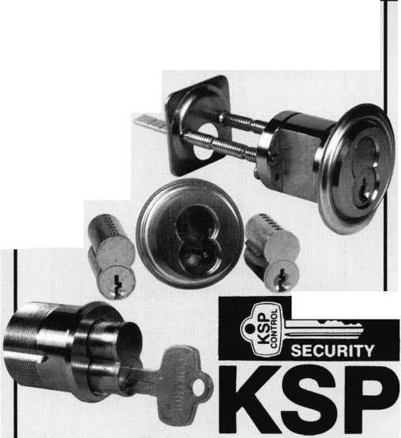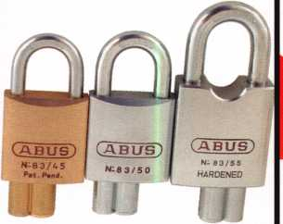

QUICK-OUT

Fits virtually all model autos. Easy to install. A child can release the trunk latch from inside the trunk to escape. Federal Law on new vehicles. A must for all others. This is probably the most important device in this catalog. Window posters and mounted locks avail­able.

QUICK-OUT

Aable Locksmith  
86-19 97th Avenue  
Ozone Park, NY 11417

718.847.1377  
FAX 718.847.0991

CCL Security Products

MAG Security Brmteb

A Gm0m ODWte lit MAC* fcilicti It Wfew*

The Adesco Guest Safe is designed for hotels, college dorm rooms, or any application where temporary storage is a necessity. The GS-5E-LTB unit is equipped with an easy-to-use elec­tronic lock, while the GS-5EC operates with the swipe of a credit card.

Adesco Guest Safe Series 2

Product

case

GS Standard Features:

Solid steel construction  
Master override key Pre-drilled bolt  
holes for simple installation (bolt  
included) Hand-felted false bottom  
hides anchor holes, Multi-language  
guest instructions, Attractive two-tone  
epoxy-based paint finish.

CCL Security Products is proud to introduce the K440 Sesamee padlock. The K440 has a four- inch shackle, which gives you the largest clearance out of any Sesamee on the market today. Remember, when looking for the best quality in cam, desk, cabinet, or drawer locks look no further than CCL.

CCL Security Products

199 Whiting Street  
New Britain, CT 06051

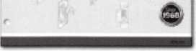

MAG Security is well known as the inventor and manufacturer of the Install-A-Lock door security plates. Today we provide over 600 items of door and window security products including M.A.G. Install-A-Locks, latch Guards, Filler Plates, specialty Strikes and numerous auxiliary win­dow & patio door items.

ABUS Lock Co.

ABUS is pleased to introduce it's new product specification and price book which features over 200 new products and accessories for the locksmith mar­ket. The ABUS motorcycle lock line is also featured which includes chains, locking cables, brake disk locks and cut resistant U-Locks.

Featured product:The Heavyweight Padlock series. Don't miss out on

860.339.6199  
FAX 860.223.7601

[www.cclsecurity.com](http://www.cclsecurity.com)

M.A.G. Engineering

15261 Assembly Lane  
Hunting Beach, CA 92649

(P) 800-624-9942  
(F) 714-892-6845

these heavy duty locks.

For more information on the ABUS  
Padlock Line please call:  
1-800-352-2287

Keynotes

June 2001

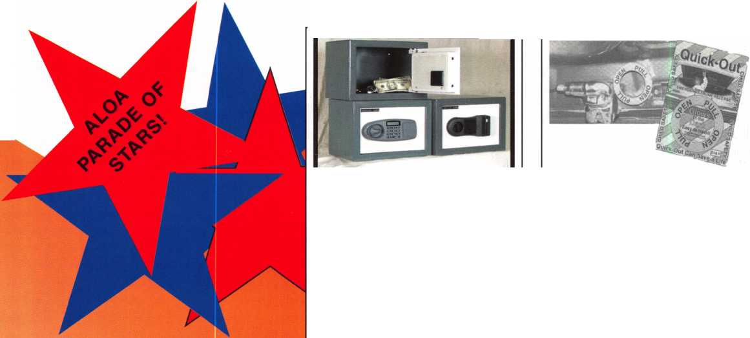

It’s SHOWTIME! I Meet some of our I newest STARS at ALOA.I

**LOCKMASTERS®, INC.**

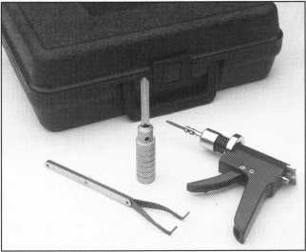

Magnum Bullet™ Drill Rig

(Patents #5-984-594)

The Magnum Bullet is a heavy-duty

Designed with new barrel and quill assembly technology, the Bullet is lightweight, quick and easy to set up, and offers template drilling. The template provided with the Bullet includes drill points for the fence, lever screw, relocker and scope for S&G, Ilco and La Gard locks. Other templates are available for the Mas-Hamilton X-07, Mosler and Star Round Doors.

MAG45701 $659.00

Rig with Case

To order, cal! t-800-654-0637.  
E-mail: [salesinfo@lockmasters.com](mailto:salesinfo@lockmasters.com)  
[www.lockmasters.com](http://www.lockmasters.com)

**SEE OUR LARGEST EVER DISPLAY  
OF TOOLS AT ALOA!  
Lockmasters is now a full line  
distributor for ASP and STRATTEC.**

High-Security Flip Pick™

Open 1985 to current 3,5,7 and 8 Series BMWs with BMWs 2- and 4-track locks in seconds.

Lockmasters’ High-Security Flip Pick™ also opens Range Rovers with 4.0 and 4.6 liter engines. The Flip Pick safely and quickly picks the door or deck lock on these previously “impossible to open” high-security BMWs. It eliminates the need for prying door panels, windows or the use of other invasive car entry tools.

LKM2690 **....$299.00**

Additional picking blades available for VW/Audi/Porsche/Saab and Mercedes 2-Track. Picking blades sold individually for only $55.00 each.

Wafer Reader

Generate new automotive keys without  
lock removal or disassembly. The SKT Wafer  
Reader works on cars using standard wafer style

locks. Insert the tool into any door or  
deck/tailgate lock to quickly and

efficiently read the lock tumblers.

There is no need to purchase multiple  
tools. One kit covers most domestic  
and import vehicles!

SKT1 $425.00

VW Tnnl

Now program VW and Audi transponder systems. Based on the original VW/Audi VAG diagnostic tool, Lockmasters’ VWTOOL allows the locksmith to quickly and easily program new transponder keys into most VW and Audi vehicles. Once connected, the VWTOOL can be used to either program new keys when the correct module PIN number is known, or retrieve the module serial number for getting the PIN number from authorized VW/Audi dealer.

VWTOOL $1,499.00

Container Bolt Saw

The Federal Standard (FED-STD-809)  
maps out several approved opening  
techniques to open GSA types of containers.  
Lockmasters has now adapted a heavy-duty

metal chop saw to a modified  
base that uses a 12” abrasive  
metal cutoff blade. The bolt  
saw carriage is hinged and  
spring loaded making it easier  
to control the cut and safer to  
operate.

This new saw can be

attached to a container using self-tapping  
screws or a ratcheting cargo strap. Once  
attached to the container, the saw can slide  
to the proper position to cut the hardened  
bolts. Class 5 containers will require 2 cuts  
(30 minute opening) and Class 6 will require  
4 cuts (15 minute opening) per drawer.

L2028 $1,099.00

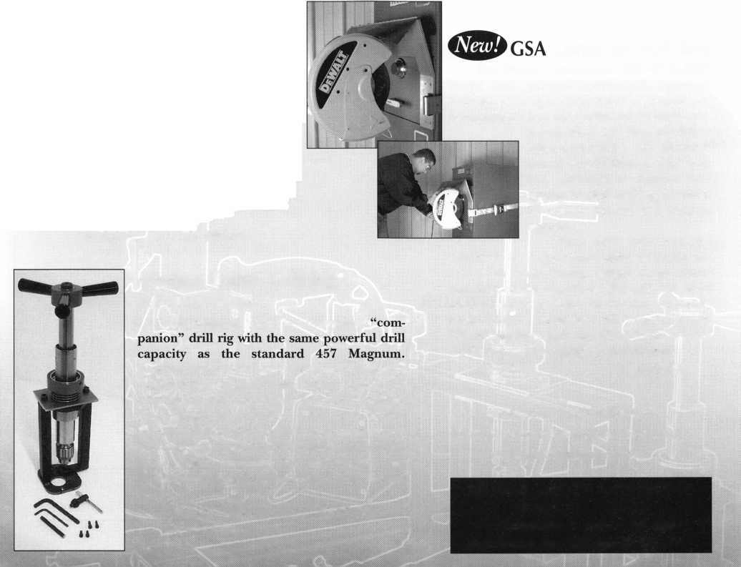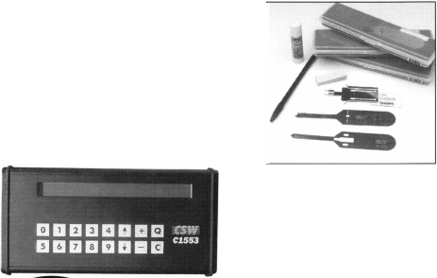

**JUNE**

3

North Jersey Master Locksmith Association 7th Annual Flea Market and Swap Meet Quality Inn Lyndhurst, New Jersey (201)944-7547

8

0* ALOA PRP Sitting Dallas, TX

Contact: Ashley Manson (214)827-1701 (214) 827-1810 fax

14-17

New Mexico Locksmith Association NMLA Convention (f ^ 6 ACE CLASSES Ruidoso, NM Contact: Steve Smith 505/281-6777

20

Central Florida Locksmith Association Access Control (Hands on)

24

Clark Security Products ALOA PRP Sitting Sacramento, CA Contact: Joan Emrick (619) 718-7308

**JULY**

13

0* ALOA PRP Sitting Dallas, TX

Contact: Ashley Manson (214) 827-1701 (214) 827-1810 fax

15-22

,0^ ^ ALOA 2001 Security Expo Baltimore, MD (800) 532-2562

**AUGUST**

10

f/ ALOA PRP Sitting Dallas, TX

Contact: Ashley Manson (214) 827-1701 (214) 827-1810 fax

**SEPTEMBER**

7-9

The Association of Ontario Locksmiths (TAOL) 28th Anniversary Convention Sheraton Parkway Toronto North Call toll free: 888-272-8265

6-9

.0* Greater Philadelphia Locksmith Association Convention & Trade Show Philadelphia, PA 8 ACE CLASSES

Contact: Nelson Dayton Reservation Chairman (610) 688-9188 FAX (610) 975-0172

14

0* ALOA PRP Sitting Dallas, TX

Contact: Ashley Manson 800/532-ALOA (2562) (214) 827-1810 fax

15

Ozark Professional Locksmith Association Annual Distributor's Show Inn of the Ozarks Eureka Springs, AR Call: 501/524-3660

27-28

^T\ MINK Convention 4 ACE CLASSES Omaha, NE

Contact: Elmer Howard (402)330-8701

**OCTOBER**

3-7

SERLAC

Education, Trade Show and Banquet Jacksonville, FL Call: 800/845-5294

12-14

Jo-Van Distributors, Inc.

Annual Trade and Educational Show Call: 416/752-2238

12

f/ ALOA PRP Sitting Dallas, TX

Contact: Ashley Manson (214)827-1701 (214) 827-1810 fax

15-21

Tri Regional Locksmith Conference 13 ACE CLASSES Portland, OR

Pacific Locksmith Association Contact: Stan Hauer (503)325-7334 Email [hauer@pacifier.com](mailto:hauer@pacifier.com) Contact: Ken Mead (503)873-6932

10-20

.0* ^ Northern Praire Chapter of ALOA Fargo, ND

Contact: Todd Ludwig, CML 701-232-9440

**NOVEMBER**

9

f/ ALOA PRP Sitting Dallas, TX

Contact: Ashley Manson 800/532-ALOA (2562)

17

ALOA PRP Sitting Grand Canyon Chapter of ALOA Contact: John Ilk, CML 602/574-5277

7-11

fjf ^ Yankee Security Convention

12 ACE CLASSES

Sturbridge, MA

Contact: Stephen McKinney

617-789-3274

**DECEMBER**

14

.0* ALOA PRP Sitting Dallas, TX

Contact: Ashley Manson 800/532-ALOA (2562)

Indicates ALOA ACE Class fjr Indicates PRP Sitting

Keynotes

June 2001



WITNESS THE **UNEXPECTED** AT THE **BALTIMORE** CONVENTION CENTER JULY 15-22

**2001 Convention Exhibitor List**

A & B Safe Corporation Aable Locksmiths Abloy Door Security Abus Lock Company Access Hardware Supply Accredited Lock Supply Co. Ace Lock & Security Supply Adams Rite Mfg. Company Adesco Safe Mfg. Company ADI, Inc.

Adrian Steel Company Advanced Security Products Alarm Lock Systems, Inc. Alarm Warehouse Alden

Allstate Insurance Company ALOA Booth

American Eagle Lock Co. American Lock Company American Security Products Architectural Control Systems Arrow Lock ASP, Inc.

ASS A Inc.

Avco Key Supply Baton Lock & Hardware Co. Bell's Security Sales Bev Key

Blackhawk Products Burg-Wachter BWD Automotive Alabama Cal-Royal Products Camden Mfg Cansec Systems CCL Security Products Clark Security Products Clear Star Security Network Commercial Van Interiors Compx Security Products

Craftmaster Curtis Industries Defiant Safe Co.

DETEX Corporation

DIDA (Wuxi Yangjian) Locks Co. Ltd.

Don-Jo Manufacturing Inc.

Doorking, Inc.

Dorma Architectural Hardware Dugmore and Duncan, Inc.

Dynalock Corporation Eclipse Ind.

Emergency Road Service, Inc.

Emtek

ESP Lock Products Inc.

Fire King International, Inc.

Fried Brothers Frontier

Gardall Safe Corporation

Guardian Security Products

H.E.S., Inc.

Handi Disc/Bits

Hayman Safe Co.

High Tech Tools

Howard Keys

HPC, Inc.

IDN Corporation

llco Unican/MAS Hamilton

Ingersoll-Rand Company

Innovative Moving Systems, Inc.

Institutional Locksmiths Association

International Association of Investigative Locksmiths

Jackson Corporation

Jet Hardware Mfg.Company

KABA High Security Locks

Keedex Manufacturing

Keri Systems, Inc.

KEY-BAK/West Coast Chain Mfg

KSP

Kustom Key

La Gard Inc.

LAB Security Lockey Corporation Lockmasters, Inc.

Locksmith Publishing Corporation Lucky Line Products, Inc.

M.A.G. Security Major Manufacturing, Inc.

Markar Products Inc.

MARKS, U.S.A.

Maryland Locksmith Association Master Lock Company Maxtech America Inc.

Mayflower Sales Corporation Inc. MBA-USA, Inc.

MCS Communication Systems MDS Incorporated Medeco

Michael J. Walsh & Associates Midwest Wholesale Hardware MIWA Lock USA Monaco Lock

Monarch Tool & Mfg. Corporation

Mul-T-Lock USA, Inc.

National Auto Lock Service

National Locksmith Association of Canada

Nostalgia

Olympus Lock Company Omaha Wholesale Hardware OS I Security Devices PDQ Manufacturing PFH

PLUS Group

PRO-LOK

RA-Lock Company

Rodman & Company

ROFU International Corporation

RSR Group Inc.

Rutherford Controls Inc.

S. Parker Hardware Mfg.

Sargent & Greenleaf, Inc.

SARGENT Manufacturing Company

Schwab Corporation

Secura Key

Secure Industries

SecureRite.com

Securitech Group, Inc.

Securitron Magnalock Corporation Security Distributors Inc.

Security Door Controls Security Lock Distributors Security Resources Inc.

Select Products Limited SentryLok, Inc.

Siedle Communications Somerset Security Products Southern Lock and Supply Company Southwest Specialty Products Speedypik

Stone & Berg Wholesale STRATTEC Security Corporation Strong Arm Security, Inc.

Sun Safes Mfg.

Supra Products, Inc.

Taylor Security & Lock The National Locksmith Turn 10 Wholesale U.S. Lock Corporation Van Lock Company Videx

Visonic Inc.

Wide Perspective Design Wilson Bohannan Company Wilson Safe Company W-Lok Corp

Yale Security Group, Inc.

Zipf Lock Company

June 2001

***Keynotes* | 15**

The best of both worlds-

Bringing EAC and mechanical locks together

-Warren Schimizzi

W

ell folks, the floodgates have been  
opened. Just a few pages into just  
about any locksmith trade magazine

and you can see the waters are chock full of  
every kind of electronic access control system,  
device and gadget one can imagine. Trouble is,  
no matter what you end up putting on your cus-  
tomer’s door in regards to access control, they  
will almost certainly have to carry two separate  
credentials: one for their EAC device, and a good  
ol’ cut key for their mechanical locks. It seems on  
the surface to be just a minor inconvenience.  
But, if you are to provide your customer with the  
highest possible security, you need to under-  
stand the inherent deficiencies in such a system,  
and how you can remedy them.

These deficiencies include:

1. The need for multiple credentials because of  
   multiple EAC and mechanical systems
2. Users forget or lose their credentials
3. Credentials are duplicated without authoriza-  
   tion
4. Credentials wear out and must be replaced

Keynotes June 2001



A solution to  
these problems  
exists. It’s the  
M e d e c o (r)

SiteKey(r) dual  
credential (fig.

1). By taking  
the already  
proven, patent

protected Medeco key and attaching an electron-  
ic head, the SiteKey credential offers a high secu-  
rity solution second to none. Advantages of using  
this technology are plentiful. First, the flexibility is  
tremendous. Take a look at figure 2. With a tradi-

t i o n a I  
mechanical  
lock system,  
the easiest  
way to secure  
both the  
entrance  
doors and  
individual lab  
and office

doors would be to key them all to their own  
change keys. The drawback to this is each user  
must carry several keys: one for the main  
entrance door, one for the sector entrance door,  
and one for their office or lab. This is the most  
secure method, but also the most inconvenient.  
Another method would be to cross key the main  
entrance and sector entrance cylinders to allow  
individual user keys to operate it. However, cross  
keying lessens security, can shorten mechanical  
life and limits the system’s future expansion and  
flexibility. Yet another method would be to install  
card readers on the main and sector entrances,  
then mechanical cylinders on the labs and offices.  
Again, the user must carry multiple credentials.  
Push button locks used on the main entrance  
could eliminate the need for multiple credentials,  
but then you are faced with the problem of no cre-  
dential accountability or key control management.

By installing a SiteLine(r) EAC system on the  
exterior doors and Medeco Biaxial(r) or  
KeyMark(r) cylinders on the offices and labs, all

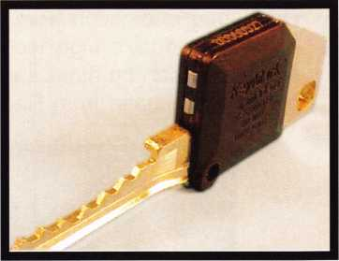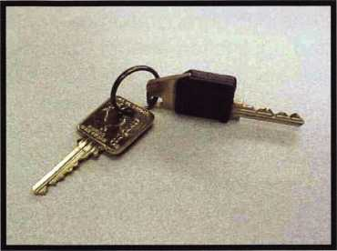

hardware can be made to work with one type of credential. As a result, each user carries only one powerful SiteKey that can be programmed into both the main and sector entrances, and also allows them mechanical access to their own lab or office. The SiteKey dual credential system will also make administration simpler due to the fact that only one type of credential is used throughout the entire system. Medeco’s SiteLine family contains electronic hardware to retrofit existing hard wired Weigand(r) 26-bit systems, as well as complete stand alone systems for small to medium installations. All of your bases will be covered because you can choose from a variety of electronic access control products and integrate them into an existing Medeco key sys­tem. In addition, Medeco dealers may choose to participate in the SiteLine Seeding Program that can greatly increase your customer’s interest. This program involves issuing Medeco mechan­ical keys that sport black “dummy” heads that can later be upgraded to an EAC credential. As you can see in figure 5, the key head states this upgradeability letting each of your Medeco cus­tomers know that their system is not limited to mechanical locks.

Let’s take a look at the “forgetablity factor”. Let’s say I’m just your average Joe Accountant, work­ing for your average widget company. Each day I have a million things on my mind before I get to work, remembering to bring that new access control card my company’s security director gave me may not be one of them. As a result, I leave my new card on my kitchen table at home, drive to work, and a co-worker lets me in. If that hap­pens on the first day of use for the new EAC sys­tem, what’s to prevent me from forgetting my card everyday? Or, worse, I leave the credential hanging from the sun visor of my car just so I won’t forget it. Talk about a potential loss of secure key control!

Now let’s look at the solution. Figure 3 is a SiteKey credential on a key ring. Most people drive their cars to work every day, and the SiteKey(r) credential would hang right along with the other keys on their key ring, never to be for­gotten again.

How about protection from unauthorized dupli­cation? In today’s high tech world, many EAC credentials can be duplicated with gadgets any­one can purchase from Radio Shack or on the

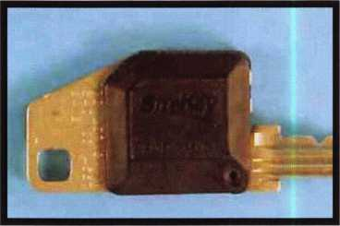

Internet and are not as secure as most people think. Medeco has built a reputation on control­ling unauthorized duplication through the use of patent protected key blanks. If Medeco is the only manufacturer of a particular key blank, and the blanks are only available for sale to Medeco authorized dealers who follow key control proce­dures then only someone who is authorized to purchase a duplicate can do so. The same holds true for SiteKey blanks. One patent protects the key blank portion of the key, and another pro­tects the combination of the mechanical and electronic technologies on the same credential. In addition, the Dallas Semiconductor chip used in the SiteKey’s electronic head has about a gazillion different electronic combinations.

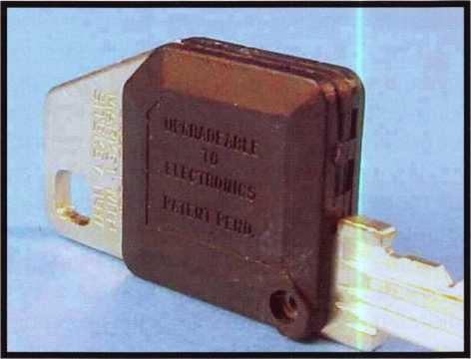

(Dallas DS1981U-F3 chip utilizing a 12 digit hexadecimal code) Feel confident in telling your customers that unauthorized duplication of SiteKeys would be very unlikely.

Keynotes

June 2001

Value. In the access control world it should be a major consideration when investigating the pros and cons of EAC credentials. How durable are the credentials? How often will they need to be replaced? How much will that cost my customer annually? Ask the administrator of a large card access system how much time and money they spend replacing damaged or lost credentials each year. You may be a bit surprised.

The Dallas chip used in the electronic head of the SiteKey is shock resistant, waterproof, and highly resistant to electrostatic discharges. The SiteKey only makes contact with a Medeco SiteLine reader at two very small contacts in the head of the key. (Fig. 4) This minimizes wear caused by friction, as you might see on magnetic stripe cards. The blank portion of the credential is nickel silver alloy, mak­ing it extremely strong and wear resistant.

The initial investment in SiteKeys might be more expensive than proximity or magnetic stripe cards, but your return on investment can be realized in the reduction of replacement credentials required and greater credential security.

Today’s security industry seems to become more  
and more divided each day. The electronic world is  
growing at a dizzying pace. The world of mechani-  
cal high security locks is constantly trying to keep  
up. What SiteKey provides is a method of bringing  
these two worlds together...and doing so with the  
highest level of security you can buy.

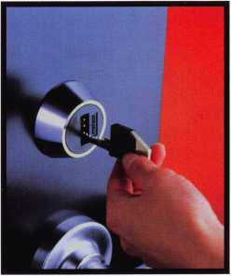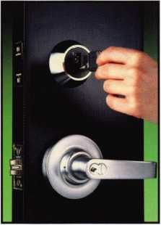

Lab Entrances

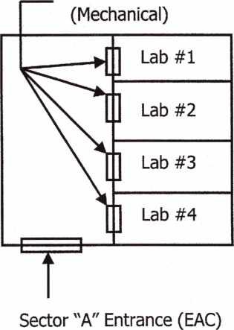

|  |  |
| --- | --- |
| Office #1 | Office #2 |
| Office E (Meet | Entrances  lanical) |

Sector "B" Entrance (EAC)

T

Main Entrance (EAC)

June 2001

Keynotes

SCHLAGE PRIMUS:

**HIGH**



**SECURITY**

By: A.J. Hoffman, CML

The Primus is Schlage's patented sidebar cylinder and  
key designed for key control, pick resistance and attack  
resistance, and was introduced in 1989. It is compatible  
with most of Schlage's keyways and can be integrated  
in most existing six-pin Schlage key systems. The three  
major features Schlage points to with regards to Primus  
are the system's flexibility, conversion capability and  
serviceability.



Mix and Match

It's possible to change the level of security with the Primus,  
depending on the level needed for each lock. When planning  
a new system, Primus is more economical than most other  
high security cylinders. You don't have to pay for high secu-  
rity cylinders on each door. You can choose, for example, to  
install conventional Schlage cylinders in most locks, Primus  
Controlled Access cylinders in the areas where positive key  
control and pick resistance are required and Schlage Primus  
UL Listed high security cylinders where you need resistance  
to drilling and other physical attack.

Conversion Cylinders

Primus cylinders are available to retrofit most popular Grade  
1 commercial locks by Corbin Russwin, Sargent & Greenleaf  
and Yale. This means you don't have to buy all new hardware  
to convert to a Schlage Primus system.

Easy Serviceability

Most servicing ids done with a standard Schlage pin kit. The  
patented side bitting is cut into the key blanks at the factory.  
If you are authorized to have access to key blanks, you don't  
have to invest in any specialized machinery to cut the keys.

June 2001

201 ***Keynotes***

The Primus cylinder begins with a conventional Schlage six-  
pin mechanism using the same pin kit and key bitting spec-  
ifications as in all other Schlage full size cylinders. This  
means you don't generally need any specialized tools or  
equipment to service Primus cylinders if you're already  
equipped to cut conventional Schlage keys and pin conven-  
tional Schlage cylinders.

To this basic mechanism, Primus adds a sidebar and five  
special L-shaped pins called "finger pins" each with its own  
spring. The cylinder shell has a groove for the sidebar to lock  
into.

The Primus key has a secondary bitting on the side of the  
blade. EAch of these cuts not only lifts its finger pin, but also

swivels it to one of three  
angles within its pin  
chamber. The correct  
side bitting raises and  
swivesl each pin to a  
position where its gate  
or opening aligns with  
the fence or protrusion  
within the sidebar.

When all gates are  
aligned with the sidebar  
and the six regular cuts  
align the regular pins at  
the shear line, the plug  
is free to rotate.

(Diagram 1)

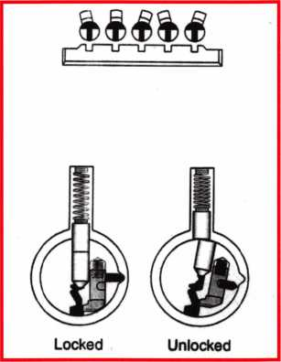

(Diagram 1)

Serving: Reading Keys

Schlage key gauge 40-104 is used to read the 6-digit conventional combination or bitting of Schlage keys. The bitting is read from bow to tip, and must always have exactly six digits. Insert the key into the wide are of the slot in the gauge. Hold it so the first cut (notch) is in position and slide it toward the narrow end of the slot. The key should stop right on one of the numbers.

finger pin to one of three angular positions (left, center  
and right) relative to the centerline of the finger pin.  
This aligns the finger pin gates with the sidebar.

The first step in reading the side bitting is to visualize

the centerline refer-  
ence for each side  
cut exactly between  
the conventional  
cuts. This makes it  
easier to read a cut  
key than a key  
blank.

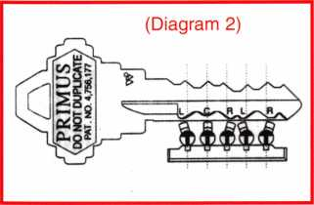

When reading a side  
bitting, be sure you  
picture an imaginary  
center line between  
the roots of the con-  
ventional cuts. Do not  
focus on the steeples  
between the cuts

because their positions vary with the relative depths of  
the neighboring cuts(Diagram3).

If you have a  
Primus plug of the  
right keyway, you  
can use it as an  
aid to key reading.  
With the key  
inserted into the

empty plug, look into the finger pin chambers and you  
will be able to see very easily whether the cut is left,  
right or center for each position. Each of these angles,  
in turn, has two possible depths: deep or shallow. The  
increment is large enough to read by eye. (diagram 4)

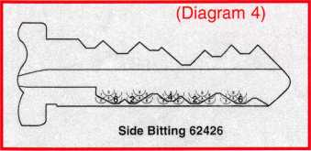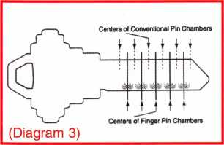

Side Cuts

For most of Primus servicing, you won't really have to read keys or change any finger pins in the cylinders because everything you work on will have the same side bitting. For commercial locksmiths, however, it is helpful to be able to read side bittings in case you need to communicate with the Schlage factory about other key systems you may be called upon to service.

To introduce key reading, we will begin with the basic interaction of the key, finger pins and sidebar. In addi­tion to raising the finger pins to the right height, the root of each side cut swivels the tip of the L-shaped

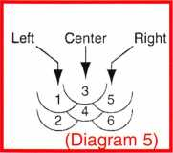

Here are those six possible cut root positions enlarged for a bet­ter view. There are three angles (Diagram 5).

Note that the two center cuts are half a

depth shallower than their left and right counterparts. Even  
numbers designate the deep cuts and odd numbers designate  
the shallow cuts. Go through this analysis for each cut until  
you have determined all five digits of the side bitting.

June 2001

Keynotes

Reading Finger Pins

Learning to read finger pins is useful if you spill your pin kit or you suspect that some of the pins are mixed within a compartment. You may notice a difference in the shape of the bottom of the finger pins. The design was changed in 1998. The difference doesn't affect the technique for reading pins (Diagram 6).

For best results, use tweezers with a point small enough to fit inside the  
gate and grasp it by the web. With the pin held in this way, pretend it is a  
boot and hold it with the toe pointing away from you, as if you were going  
to put it on. In this position, you should notice that the direction of the toe  
points to the angle of the pin (left, center or right).

**Keying Procedure**

(Diagram 6)

Insert sidebar springs and sidebar into slot in the plug (Diagram 7). Slide  
the plug into the holder upside down with the sidebar extending into  
groove in plug holder cavity. Now insert a finger pin spring into each  
of the five finger pin chambers (Diagram 8). Next, determine the correct  
five-digit side bitting in order to select proper finger pins from the kit.  
Now you can install the finger pins one at a time from front to back,  
pushing the key into the plug to hold the pins in place. Maintain light  
pressure on the finger pins while inserting the key. With all finger pins  
installed and the key fully inserted, turn the plug 180 degrees to  
expose pin chambers on top (Diagram io). IF the plug does not turn, one  
or more finger pins are wrong. If you are masterkeying, use a setup

key cut to all #9 depths (Diagram ii) for this procedure in order to make  
room for any possible combination of bottom pins and master pins.  
Now you can install all six bottom pins and any master pins required.  
Add a very small pinch of dry graphite to each pin chamber.

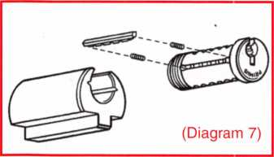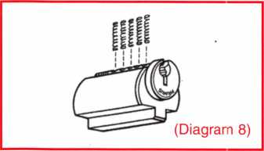

c DU

X7

c ::

Old Style

New Style

Left

Tweezers



Center

Right

A A

(DiagramlO)

(Diagraml 1)

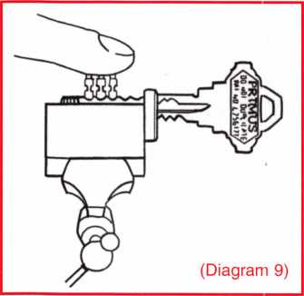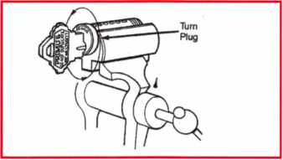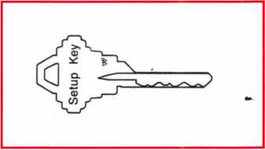

June 2001

***22 l Keynotes***

Select the proper length of the top pin for each chamber and load the top pins and springs into the cylinder shell.

The top pin size is determined by the total of the bottom pin and master pin in its chamber (Diagram 12)

Top Pin Selection

|  |  |  |
| --- | --- | --- |
| Plug Total  n | Pin | Length |
| 1 I o, 1,2,3 | 1 | .235" |
| LJ 4, 5, 6 | 2 | .200" |
| 7,8,9 | 3 | .165” |

(Diagram 12)

Remove the plug from the plug holder with the key still in place. Maintain pressure on the sidebar as the plug comes out. With the plug rotated slightly (with respect to the shell), slide it into the shell. From here, you simply complete the cylinder assembly like any conventional Schlage cylinder.

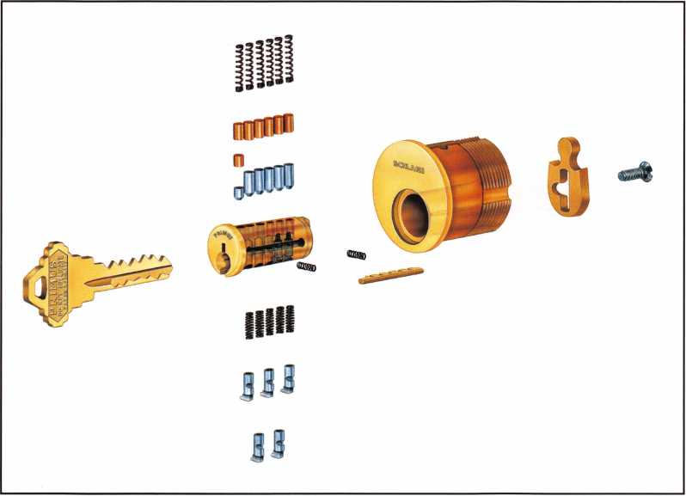

*SPEEDYPIK®*

THE AUTOMATIC  
KEY IDENTIFICATION  
SYSTEM

* Preprogrammed database with full side view
* Automatic inventory control and reorder program
* Create your own database(s) to match your keyboard
* Hire inexperienced personnel without training

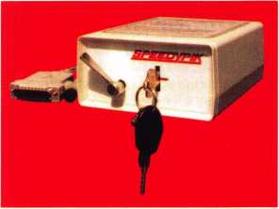

THE AUTOMATIC  
KEY DECODER SYSTEM

* Eliminates measuring each cut in  
  a key
* Eliminates looking in pinning  
  charts
* Portable, hand-held, battery-oper-  
  ated
* Connects to your computer (serial  
  port)
* Complete scan & readout in  
  seconds

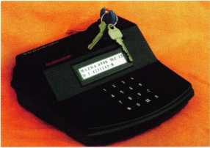

Phone: 617-567-1111  
Fax: 617-277-7777

E-Mail: SPEEDYPIK @  
AOL.COM

[www.SPEEDYPIK.com](http://www.SPEEDYPIK.com)

June 2001

Keynotes



**lassroom Security**

A New Lock Function from Medeco

by Sal Dulcamaro, CML

The security of the classroom has been called into question by news reports that also highlight gun violence in the schools. Students with vengeance on their minds stalk the hallways, ready to shoot anybody in their way. These events are much more rare than the media might suggest, but they do call attention to security lapses in the school envi­ronment. The focus of the institutional locksmith may be to start pointing out the short­comings of the traditional classroom function hardware. The lock must always open from the inside, but there is no locking button for the inside knob that would allow mischievous students to lock out the teacher. It can only be locked or unlocked on the outside with a key.

In recent years, there has been a dramatically heightened perception of risk and danger in the school environment. What happens if there is an intruder in the school? If a teacher hears gunfire in the hallway, there are two choices. The teacher can venture into the hallway (and the line of fire) to use the key to lock the outside knob, or wait inside with the door unlocked and accessible to the intruder. Neither option is comforting. Where do you find a lock that can be locked from the inside in an emergency, but where the students will not be able to lock out the teacher? Meet the classroom intruder function lock from Medeco.

Photograph 1 shows the Medeco (preassembled) grade 1 key-  
in-lever lockset. Medeco’s classroom intruder cylindrical lock is avail-  
able in a few different lock cylinder versions. It is available in two lever ..  
handle styles. You can order it with a Medeco high security key-in-lever  
cylinder, or your choice of Medeco high security 1C or KeyMark 1C (both  
with lever handles). The version of the lock used for this article and the  
one displayed in photograph 1 makes use of a small format 1C (SFIC)  
KeyMark lock cylinder.

Lock Installation

Like most heavy duty lever handle cylindrical locksets, you will  
need to drill two through-bolt holes in addition to the standard prep 2 1/8  
inch diameter cross bore hole. The lock comes with a paper template,  
or you could use the Marks J295 Lockset Installation Tool shown in pho-  
tograph 2. The tool, as shown, is set for 2 3/8 inch backset. You can  
switch to 2 3/4 inch backset by reattaching the corner bracket (edge ~  
guide) on the opposite side with the two thumb screws. Photograph 3  
shows the other side of the tool with the circular projection that fits into  
the cross bore hole to help keep the tool from wandering while you drill.

The jig is attached in photograph 4. It is not clamped in place,  
although you could probably use a clamp to hold it more securely while  
drilling. Otherwise, you would hold the jig in place with one hand while  
drilling the holes with the other. It would be smarter to drill part way  
through on both sides of the door, rather than to drill all the way from  
one side. Drilling from one side will tend to be less precise, and it also  
tends to cause splintering or burring on the side that the drill comes  
through. With the jig removed, in photograph 5, you can see the  
through-bolt holes just above and below the main cross bore hole. ^

Lock Construction

The partly preassembled lock in the box has to be partly disas-  
sembled before it can be installed on the door. For the KeyMark 1C ver-  
sion that I was using, I had to first remove the interior handle 1-Core. I  
believe the locksets come standard without cores, so you may not have  
to worry about this step. I’m not sure if the non-IC versions also come  
less cylinder. The control key is used, in photograph 6, to pull the core.

The core is completely out in photograph 7, and the open cav-  
ity of the 1-Core housing reveals a cross shaped opening for the lock  
cylinder tail piece. It is dimly lit that far into the opening, so it may not  
be easy to see that opening clearly in the photograph. The core must .  
use a tail piece adaptor, since there are not fixed drive pins in the lock-  
set’s 1C housing cavity. A six pin 1-Core is used here, but a shorter tail  
piece would probably be required if a seven pin core was used. My  
guess is that a “less core” lockset would include both length tail pieces.

The inside lever handle must also be removed. On the 1C ver-  
sions of the lockset, there is no exterior access hole. The handle retain-  
er must be accessed through the 1-Core housing cavity, a small screw-  
driver or other tool can reach back into the opening and pull in the  
retainer to release the lever handle. If it had been a non-IC version lock-  
set, you would likely find the retainer access hole near where I am point-  
ing the screwdriver tip, in photograph 8. After removing the lever han-  
dle, you must also remove the inside rose assembly. Both parts have  
been removed in photograph 9. I am pointing to the retainer with the 0screwdriver tip. The retainer was pushed in to remove the inside rose  
assembly, too.

Door Thickness Adjustments

The lock is adjustable for doors between 1 5/8 inches and 1 7/8  
inches thick. A paper door thickness gage is shown in photograph 10.

The dimension indicator mark should be in the center of the latch retrac-  
tor. You can see that this lock is set at the factory default setting of 1 3/4

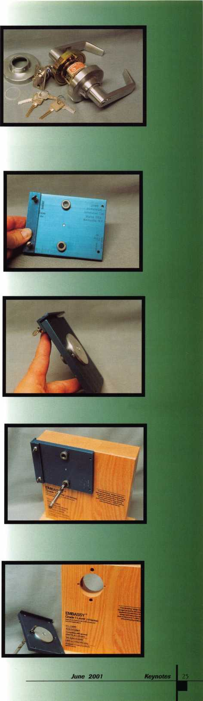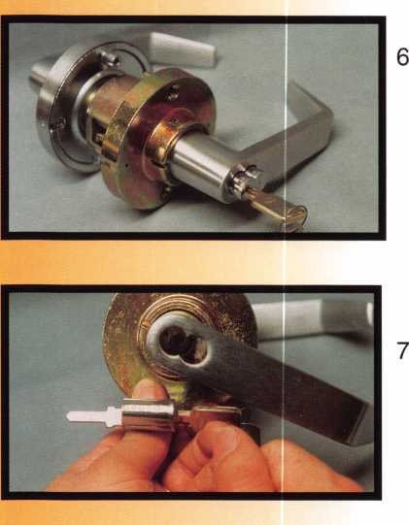

inches thick. To change the setting, you would have to first remove the out-  
side lever handle (removing the 1-Core first), and screw the outside rose in  
or out to the correct setting. Removing the outside handle would be simi-  
lar to what I did with the inside handle.

Assembling the Lock

After installing the latch, push the lock through the 2 1/8 inch cross  
bore hole so that the latch retractor properly engages the latch, as in pho-  
tograph 11. The screw posts should fit in the through-bolt holes. The inside  
rose assembly is ready to install in photograph 12. When you slide the rose  
far enough inward, it will catch on the retainer. Then you would insert the  
two through-bolts and tighten.

A “stepped” plastic washer is positioned between the inside rose  
assembly and the inside rose cover. I am holding the plastic washer in pho-  
tograph 13. The inside rose cover is on top of the lock mount. It is a slight-  
ly awkward move to keep the washer in place while attaching the rose  
cover. The rose cover is attached in photograph 14, with the narrow side  
of the plastic washer slightly protruding. There are retainer access holes  
on each side of the cover, but the retainer is only accessible through those  
openings for non-IC versions of the lock. The inside lever can then be slid  
on over the lock tube and pushed in until the retainer catches, as in photo-  
graph 15. All that is left is to re-install the 1-Core with the control key.

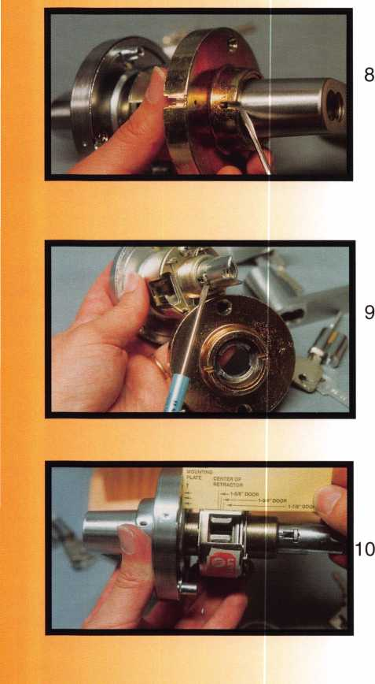

Keynotes

June 2001

Lock Timing

If not already accounted for, you should verify the lock timing,  
before installing the 1-Core. Timing is an important consideration on cer-  
tain brands of classroom function cylindrical locksets (Medeco included), in  
order for the locking and unlocking operations to work properly. To lock the  
outside handle, you would insert the operating key and turn it 360 degrees  
counterclockwise, and then remove the key. To unlock the outside handle,  
you would do the opposite. After inserting the key, you would turn the key  
360 degrees clockwise and then remove the key.

I earlier mentioned the cross shaped slot that is engaged by the  
lock cylinder tailpiece. You set the timing by positioning that mechanism  
before installing the 1-Core. You would have a similar situation with the non-  
IC lock versions, but with a non-IC lock cylinder. With a flat tipped screw-  
driver or similar tool, engage the slot and rotate clockwise until it stops.  
Then install the 1-Core. The timing can be tested by using one of the oper-  
ating keys and turning the key a full 360 degrees counterclockwise. If it  
can’t turn far enough to reach the key removal position, the timing of the  
mechanism is off. The outside handle lock cylinder should also work the  
same way.

Lock Operation

The classroom intruder function lock can do all the things that a  
standard classroom function lock can do, but it can also be locked or  
unlocked (by key only) from the inside. This lock uses a clutch device for  
the outside handle, so when locked the (outside) lever handle will still turn.  
It just won’t engage the latch. Photograph 16 shows how it works in the  
locked mode. The outside lever is pulled all the way down, but the latch  
remains extended. To unlock the outside handle, you can turn the key 360  
degrees clockwise (from inside or outside lock cylinder), and remove the  
key. Turning the handle, in photograph 17, will now retract the latch.

Turning the inside handle will always open the door, and the out-  
side handle can only be locked or unlocked with a key. That describes a  
classroom function lockset. What the classroom intruder function adds is  
locking or unlocking the outside handle from the inside. Photograph 18  
shows the outside 1-Core being pulled with a control key. It is important  
when rekeying this lockset (1C or othewise), that both inside and outside  
lock cylinders be keyed to match. If the teacher’s key works only the out-  
side cylinder, the benefits of this lock function are defeated.

Important Information

You will rarely (if ever) run into a double cylinder lock  
in a school. When you look at the completed installation, it is  
difficult to figure which side is inside and which is outside.  
When in the unlocked mode, both handles look identical and  
they both actuate the latch. In the locked mode, the clutch  
operated outside handle will turn without drawing in the latch.  
If installed backward, there would be serious life safety issues  
to deal with. I think it goes without saying, that you don’t want  
to install one of these backwards.

To take apart the preassembled lock, I had to first  
remove the core and then the inside lever handle. You will  
have to do similar operations, if you wish to remove a class-  
room intruder function lock from a door. On the non-IC ver-  
sion, you will need the operating key to remove the lock cylin-  
der in order to remove the inside handle and take the lock off  
the door. The 1C versions will require a control key to remove  
the 1-Core, followed by handle removal and then taking the  
lock off the door. If you don’t have those keys, you may have  
to drill to remove this lock.

I will post some additional information and clarifica-  
tions, about subjects mentioned here, on my web site. Find  
the Lockwriter Home Page at [http://home.earthlink.net/~lock-  
writer](http://home.earthlink.net/~lock-writer). At the bottom of the home page, you should see a  
page link to “Tech Article Addendum”. You will find updates  
and corrections to my various technical articles, on that web  
page. There is also a link for you to e-mail me if you may have  
additional information about this lock or have questions.

If you want additional information about the class-  
room intruder function lock or other Medeco products, call  
800/839-3157. You can also find them on the web at:  
[www.medeco.com](http://www.medeco.com)

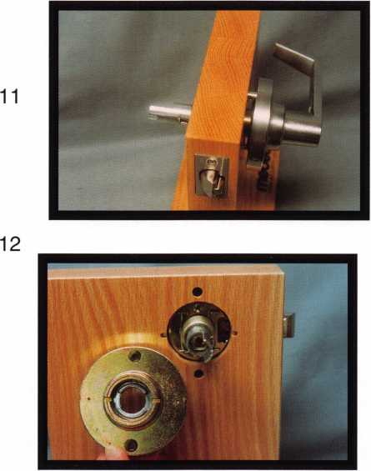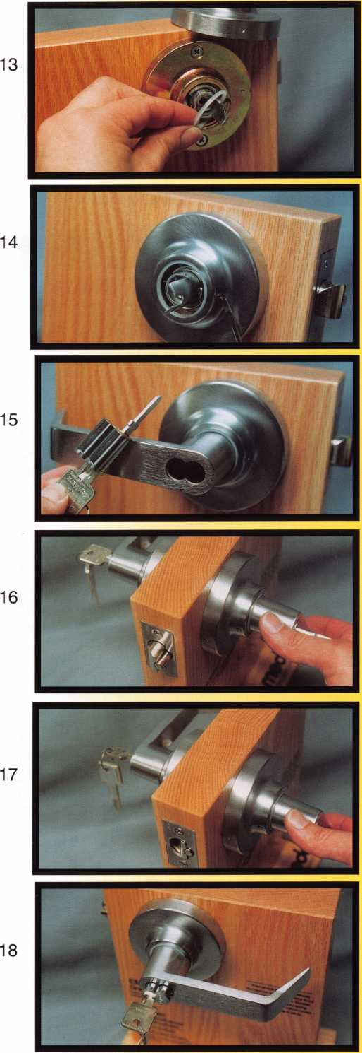

June 2001

***Keynotes*** | 27

I^Xeviving an ISM X6

By Greg Perry, CML, CPS

Hiah Security Gold Mine



Occasionally, someone will give you an old safe worth  
a lot of money restored, but how much will it cost you  
and do you have a customer who might want it? We  
were given just such a safe. It was an ISM TRTL30X6  
in very sad shape. Fortunately, it was left open, since

j|

no one could remember what the combination was or  
when they had used it last.

A customer of ours had it sitting in a corner collecting.

I say "collecting" because it was filled with dirt, water,  
rat remains, bugs and almost anything else you might  
find out in the desert. My mission was to restore it and  
find a customer who wanted to invest in a very fine  
safe. We managed to have a customer find us before  
I completed the restoration.

Keynotes

June 2001

It all started with a gold mining customer telling us  
they had this big old safe sitting out back that they  
didn't want anymore, but he hated to just throw it out.  
If we wanted it, all we had to do was haul it away.  
When my boss went out to pick it up, they were hav-  
ing trouble lifting it with their 5000-lb. Forklift. (Not a  
good sign when you have a 1-ton truck.)

He drove slowly and carefully back to the shop. The  
locks barely turned and all the bolts were heavily rust-  
ed. The rubber grommets for the glass were crum-  
bling and the paint was peeling. The only good thing  
was it looked like all the pieces were there and the  
label was still attached. This looked like one hell of a  
challenge. I'd never worked on an X6 before (let alone  
restore one), but remember, it was free.

I started drawing diagrams of everything I took apart.  
By the time I had finished, I had four hours in just  
removing all the bolts, screws, glass, wires, locks and  
gears. I never realized how many parts there are in a  
safe like this. Once all the hardware was stripped, I  
sent the bolts out to be rechromed and sent the safe  
box down to the body shop for paint. I waited to send  
the time lock off to Timemasters until the safe was  
actually sold to the customer, so they would have a  
fresh service on the movements. I figured I would  
have everything back in a month; then I'd put it all  
together and go find a customer. Well, things got busy

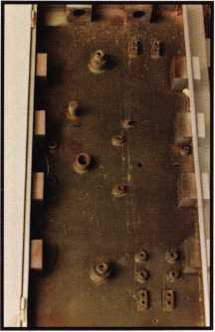

1

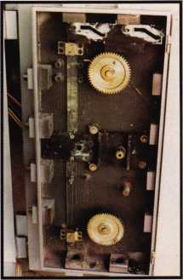

3

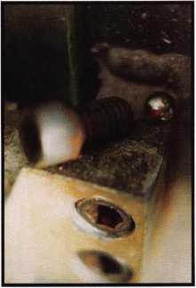

5

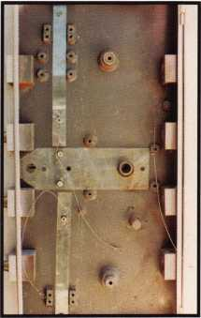

2

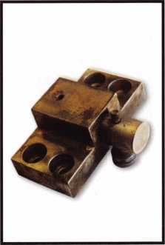

4

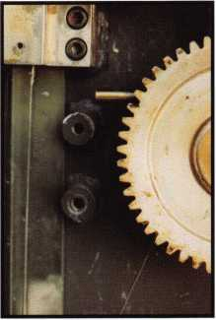

6

June 2001

Keynotes

at the shop and it sat in pieces for a year before a new gold mining customer came in looking for a "high security" safe. I was now under the gun to get it back together. I told the customer we could deliver in two to three weeks and sent the timelock off. Boy, was I optimistic. Of course, by now I had forgotten how it was assembled and could only find a couple of the diagrams to guide me. I sent the three-movement timelock off, along with anoth­er two-movement lock with it. Out of the five, Dan Graffeo, CMST, CRL, was able to put together a functional three-movement time Icok. Now the fun part: reassembly.

I started with the stripped door as seen in photo 1. The tempered glass relock plates with new grom­mets are added to the inside of the door in photo 2. Next came the gears, the lock mounting plates and the relocks attached to the wires coming from the glass plates (photo 3). Photo 4 shows a close- up of the relock while photo 5 shows the ball bear­ing that goes into the bolt hole prior to the bolt to discourage drilling. All of the attaching bolts have ball bearings behind them. Photo 6 is the upper relock in position. Photo 7 shows one of the lock­ing bolts and photo 8 is the win, which goes through the hole in the bolt to prevent driving the bolts. The completed door, less the locks, is in photo 9. Photo 10 is with the locks. Photo 11 is a close-up of the locks. The wires coming off the

9

June 2001

301 ***Keynotes***

10

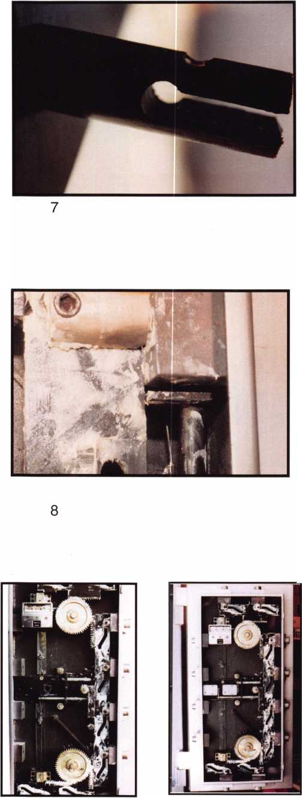

lock on the left are for the bolt position switch and a duress switch, which can tie into an alarm system. Photo 12 is the front of the door and photo 13 is the edge view.

Two months after I told the customer "a couple of weeks," the safe was ready to be delivered. The worst part of the job was delivering the safe. We hired a local trucker to haul it for us since our truck was not designed for this kind of load. The last 10 miles were down a bumpy dirt road. I kept my fingers crossed that the glass wouldn't break as he hit those bumps. I had locked the safe open for travel just in case, but my wor­ries were unneeded as the glass and the safe survived the trip perfectly.

Our so-called "free" safe ended up costing us over $2,500 in time and materials by the time we delivered it to the customer. New, this safe would have sold for around $10,000 and we sold it restored for $5500. Our customer was extremely pleased with it and we were even happier to have found a customer.

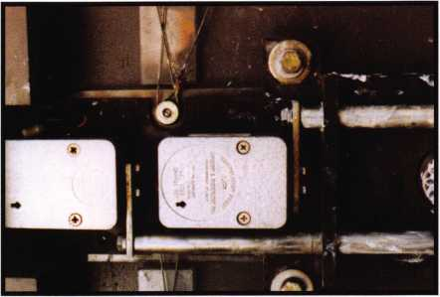

11

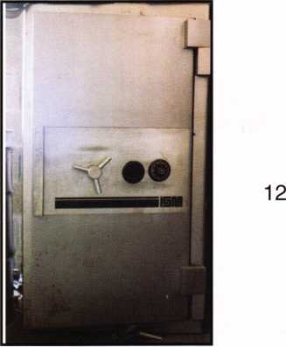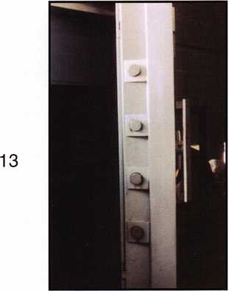

June 2001

Keynotes

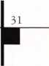

R

**EPLAl**



? SW

By Bob Arthur,

T

he 87 to 95 Nissan Pick Up Trucks  
and Pathfinders have an outside

■ lock control linkage that is readily serviceable on the lock end, but rather scary on the bottom end if you have not been in a position to become familiar with it. It requires removal of the door latch assembly in order to service the linkage rod clips on the bottom end. If you’re like me, the thought of tearing into an unfamiliar operation gives me chills.

I recently encountered a service call on a 93 Nissan Pathfinder, in which a key blank had been broken off in the ignition, and the customer advised that neither door lock was working. After extracting the broken key, and making a new one, I tackled the door problem.

I first found that the key turned the lock, but the lock did not operate the lock control on the one would assume that the clip would be broken at the lock, however, this was not to be. Instead, the lower clip which attaches the same linkage rod to the latch, was the culprit. After several attempts to get my hand in to the latch while holding



this part, I realized that I had a big problem. I could see the hole in the latch lock actuator, but there was no way I was going to get that linkage rod back in there. Furthermore, until the problem was described to me, I couldn’t even tell that the clip was broken. You have to know what your look­ing for.

I called a friend of mine who owns a Nissan body shop, and he advised me that the latch had to be removed in order to facilitate repairs. I was not pleased to hear this information, as I had never been privileged to remove the latch from a Nissan before. He swore to me that it wasn’t that difficult, but erring on the side of caution, I sent them to a dealer. Number one, I don’t like to tread too deep in unfamiliar territory. Number two, I don’t experiment on a customers car! I could see myself three hours later with a door apart, and praying I could figure the whole mess out! I’m pretty mechanically inclined, I guess I’m just not that brave!

This lower clip is made in two parts, with a plastic guard designed to prevent entry with a slim jim.The design of this guard is such, that a slim jim inserted down against the guard, will be diverted past the guard and directly into the outer part of the clip. With little effort, the two small ears on the clip will break off allowing the linkage rod assembly to disconnect from the latch. This of course pre­vents entry via the outside lock control.

Having my friend at the Nissan body shop, allowed me the time, the vehicle, and the guidance to learn the proper procedure for replacing this rascal. My friend Don was kind enough to let me experiment on his own truck in order that I might learn, as well as pass this information on to others.

Photo 1, shows the inside door trim panel. First unscrew the inside lock control button and remove it. The plastic guard around the inside handle simply snaps off by pulling it from the bottom edge. Remove the two phillips head screws holding the arm rest on, and remove it. Next

remove the window crank, this is held on by the typical  
window crank clip, which requires a clip removal tool. Once  
the window crank is removed, the trim panel is held on  
with the button type, snap in retainers. Pop these loose,  
and remove the trim panel. I have found that by popping  
the upper trim panel on the forward edge with your hand,

Photo 2, shows  
the outside door  
edge, and the  
location of the  
latch screws, and  
the lower rear  
window track bolt.

The three Phillips head screws hold the latch in place, and  
the single 10mm bolt holds the lower rear window track to  
the inside of the door frame. Before removing any of these  
screws, we must first take the following steps.

1. Remove the outside door lock, this part is held into the  
   door by a clip. Sometimes this clip gets a little rusty, and  
   requires some gentle persuasion to remove. The inside  
   linkage rod must then be disconnected from the lock.  
   Since the lower end is already broken, once it has been  
   disconnected from the lock, it will fall off into your hand.
2. Remove the 10mm bolt holding the lower rear window

track. This track is only  
attached at this one point.  
Once the bolt is removed,  
the track slides off of the  
rubber window gasket  
hanging down in the door.  
See Photo’s 3 and 4.

1. Remove the three  
   phillips head screws hold-  
   ing the latch to the door.  
   Once removed, the latch  
   will fall slightly away from

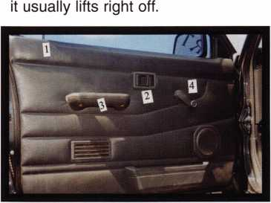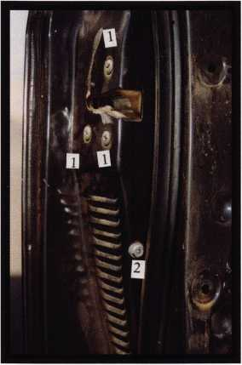

June 2001

Keynotes

the inside door frame, and the metal latch shim will fall out  
and into the bottom of the door. Simply retrieve it and lay it  
aside.

1. You can now pull the rubber window gasket up and out  
   of your way.

This part does NOT have to be removed, and no attempt  
should be made to do so. Reaching into the door, grasp  
the latch assembly, and disconnect the inside handle link-  
age from the latch. You may now pull the latch down until  
the inside lock control rod has cleared the upper door

Photo 5  
shows the latch  
assembly and  
the latch shim.  
The short link-  
age rod

attached to the  
plastic guard is  
visible on the  
top edge of the  
latch as it  
appears in the  
photo.

Photo 6

shows this linkage rod assembly, with the broken clip in  
the center of the guard. The clip itself consists of the part  
visible on the linkage rod between the two ends of the  
guard, and the small shim laying directly in front of the  
guard. The guard, and both clip parts are made of plastic,  
and after age and use get very brittle. I recommend carry-  
ing all three parts on your van. They are inexpensive, and  
worth carrying with you.

The linkage rod itself is clipped to the guard. It fits  
very tight, and usually the clip part of the guard will break  
when you remove the rod. Once unclipped, the rod will pull  
out of the guard, and the broken clip. See Photo 7.

Photo 8, shows the new clip and shim required to

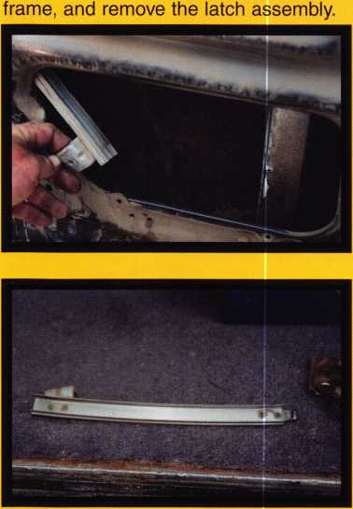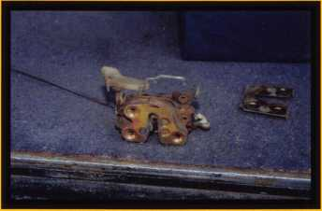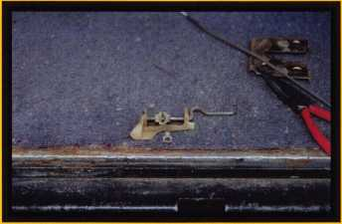

make the repairs.  
Place the new clip  
into the hole on  
the lock actuator  
of the latch as  
shown in Photo 9.

The white shim is inserted from the rear, and when in  
place, spreads the retaining arms on the clip so that it can-  
not come out of the hole. The guard is placed over the clip,

and the linkage  
rod is inserted as  
shown in Photo  
10, Once in place,  
snap the linkage  
rod back into the

clip on the guard. Note: The broken clip on the old guard is  
visible in photo 10. The old part is laying on top of the nee-  
dle nose pliers with the broken clip directly above the cut-  
ting jaws.

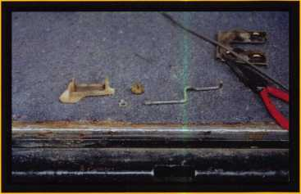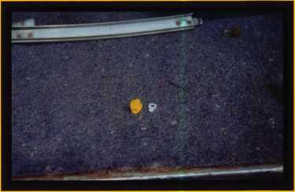

Once the linkage rod has been reinstalled on the

latch with the  
new parts, we  
are ready to  
reassemble the  
door. Taking the  
latch back to the  
door, we insert

the latch with the  
inside lock con-  
trol rod going  
back up through  
the top of the  
door frame.  
While holding the

latch in the door, reattach the inside door handle linkage rod to the latch. We must next align the latch in the door frame. Take care when aligning the latch, as the outside

June 2001

***Keynotes***

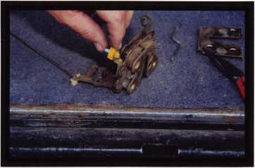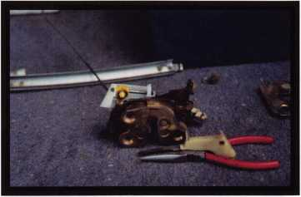

door handle linkage rod must fit into an arm on the top of

the latch. Once  
this is done, slide  
the latch shim  
between the  
latch and the  
door from the  
bottom. This part  
will only go one  
way, so you don’t  
have to worry  
about getting it  
wrong. The holes  
in this shim  
match the holes  
in the latch.

This part of the operation will test your manual dexterity a bit, as you want to get both hands inside the door and there is only room for one. Once you have the latch and the shim aligned with the holes in the door, install the three latch screws.

Next, install the outside lock and connect the link­age rod to it. Place your rubber window gasket back into position, and guide it into the lower window track. Align the window track into position in the door, and install the 10mm bolt securely. At this time, check the operation of the inside and outside lock controls and door handles. If everything is working properly, you can reassemble the door trim and the job is finished. I recommend lubricating the latch while you have it out. This simply makes every­thing work smoother and makes the job more profession­al. A good teflon type spray works very well.

This operation is not ail that difficult, and can add substantially to your profits. The dealers charge 75.00 an hour and charge about an hour and a half for labor to replace these parts. Even when the vehicle has not been tampered with, these small plastic parts wear out and break with age. I happen to live in a desert environment

where the extreme heat rapidly takes a toll on plastic. My friend advised me that this is a common problem, and they often replace these parts. Why give the job to a dealer when we can do it in the course of our daily business. Lets face it, who do the folks call first when their locks don’t work! Furthermore, the customer has to take their vehicle to the dealer, while we go to the customer.

Once you have done one of these jobs, you will never turn another away. I know I won’t, the next one will pay off for me. Even though I passed this one up, it pre­sented me with an opportunity to learn. I still won’t exper­iment on a customer’s car, but when I encounter these problems I try to learn from them. None of us can know everything about every vehicle. Maybe some of you are brave enough to experiment on a customers car, I’m not! I will be prepared for this problem the next time out, and if you follow the procedures outlined in this article, you will be also. The profits will be in your pockets and not the dealer.

NOTE:

The part numbers for the clip and shims are listed below.

Clip: (Holder Rod) 80552-34A00 Nissan Part

Shim: 80534-34A05 Nissan Part

June 2001

Keynotes

Mul- -Lock

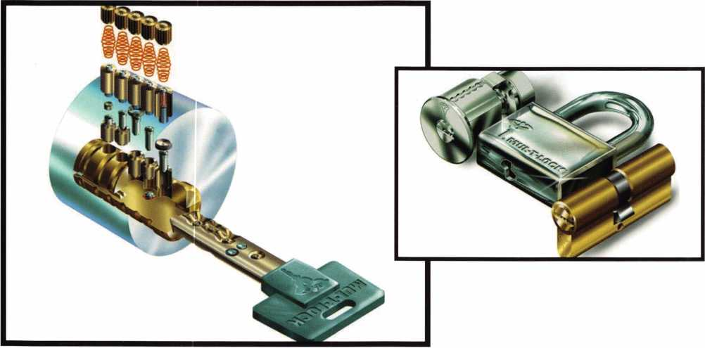

E

ach Mul-T-Lock product can be part of an inte-  
grated system.Mul-T-Lock's advanced key and  
cylinder, with their sophisticated mechanism

and telescopic tumbler pins, provide a common link  
between all the company's products. All cylinders are  
made from high quality solid brass plug and body.  
Patented ribbed plug for increased level of security.  
High precision, advanced 10 telescopic pins tumbler  
system. Patented combined driver pins. Optional

patented Interactive cylinder. Available with stainless steel or nickel silver pins. Pick and drill resistant for High Security needs. The Interactive key blank and cylinder are protected by a newly registered Mul-T- Lock® patent in the U.S., Europe and dozens of other countries, due to remain in force well into the 21st cen­tury.

Keys- Reversible nickel silver key with nylon key head and colored insert, or in all nickel silver. Unique

361

***Keynotes***

June 2001

dual concentric dimple cuts,produced by Mul-T-Lock® key cutting machine. Available in different key profiles and optional patented Interactive key.Mul-T-Lock has expanded its government, and industrial/OEM applica­tions.

Designers aim to create products that defend against almost any attempt at forced entry. At the same time incorporating a patented key control system to protect against unauthorized Key Duplication. The Mul-T-Lock cylinder is based off of a telescopic pin tumbler mecha­nism (pin within a pin in each chamber, and is protected by the Interactive key control system, which holds one of

the longest patent lifes available in the market today.

Based upon a vision of total product integration,  
Mul-T-Lock has developed a sophisticated unique access  
control system, which allows the user to operate mortise

locks, deadbolts, file cabinet locks, and

padlocks with a single key.

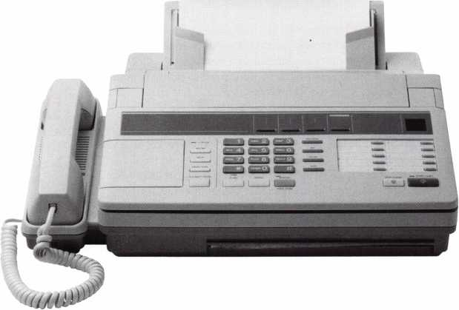

ALOA  
HAS  
FAX ON  
DEMAND!

Need information in a hurry?

Just call 310.575.5074 and you will be faxed:

Your association continues to explore  
ways to provide you, our members,  
with new benefits and services.

#1

#2

#3

#4

#5

#6

#7

#8

#9

#10

#11

#12

#13

#14

#15

#16

#17

#18

A list of all documents available through this service

Becoming A Locksmith  
Locksmith Career Summary  
Locksmith School List  
ACE Class Schedule  
Certification Information  
PRP Category List  
ALOA Membership Application  
ALOA List of Benefits  
Scholarship Application Form  
ALOA Video Library Order Form  
ALOA Membership Items Order Form  
Safe & Vault Technicians Association  
Member Application/Subscription Form  
ALOA Chapter Roster  
Legislative Action Network  
Legislative Action Network Newsletters  
Various State Laws  
Industry Position Paper

June 2001

Keynotes

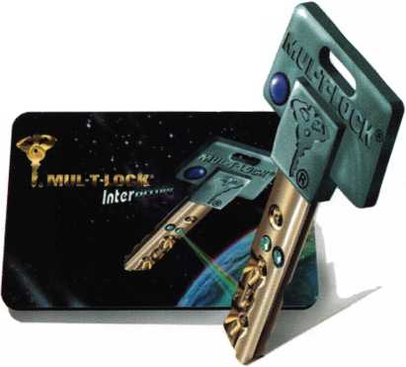

**CHECK OUT ALOA’S NEW ON LINE LEGISLATIVE TOOL!**

Go to <http://www.aloa.org/news/legislationcfm> and check out ALOA’s new on-line service that connects locksmiths to every member in their state legislature. It provides up-to-date information about key issues and gives users quick and easy access to state officials. You can contact legislators by customized or personalized e-mails, faxes or standard letters. It also conducts a 5 and 9-digit ZIP Code search so that you can identify your state and local officials quickly. Check it out today!

**CONNECTICUT SB1323**

Established licensing and examination requirements for home improvement contractors and telecommunications infrastructure layout technicians. Substituted bill now only licenses Telecommunications Infrastructure Layout Technicians.

STATUS: 04/11/2001 Committee Substitute reported out of Legislative Commissioner's Office 04/11/2001 Reissued by Legislative Commissioner's Office with File No. 229

**ILLINOIS HB26**

Provides that giving notice to the public by yellow page advertisement, through a sign at the facilities of the towing service, or by any other adver­tisement, that the towing service opens motor vehicle locks to enable a vehi­cle to be moved without towing does not constitute holding oneself out to the public as a locksmith if the advertisement does not use the word “locksmith”.

STATUS: 03/27/2001 Tabled by Sponsor.

**ILLINOIS HB2219**

As introduced, changed definition of burglar alarm system to include CCTV. NOW, only makes a technical change for restoration of a license after disci­plinary proceedings

STATUS: 04/06/2001 Rereferred to House Committee on Rules.

**ILLINOIS HB2536**

As introduced, allowed for electronic fingerprints. NOW, makes a technical change concerning the temporary suspension of a license

STATUS: 04/06/2001 Rereferred to House Committee on Rules rules.

**ILLINOIS SB115**

Provides that no vehicle dealer may issue to any person a new key to a vehi­cle unless the person can prove ownership

STATUS: 05/02/2001 In House. Amendment No. 1 filed. To House Committeon Rules To House.

05/02/2001 In House. Held on Calendar Order of Second Reading.

**ILLINOIS SB967**

Provides for regulation of electricians and electrical contractors; provides that performing unlicensed electrical work, when a license is required by this Act, constitutes a business offense for the first violation and a Class A mis­demeanor for a second or subsequent violation; provides for concurrent exer­cise by home rule units

STATUS: 03/31/2001 Rereferred to Senate Committee on Rules.

**MARYLAND HB224**

Authorizes the Secretary of State Police to adopt regulations to establish fines for specified violations; requires specified individuals to be licensed as private detectives, security guards, or security systems technicians by the Secretary of the State Police before soliciting and engaging in business.

STATUS: 03/02/2001 Passed House. To Senate. 04/05/2001 Passed Senate. To House for concurrence.

**MARYLAND HB1368**

Tightens the definition of Security System to include locks, electronic access control, alarm and closed circuit television.

STATUS: 03/26/2001 From House Committee on Commerce and Government Matters: Reported unfavorably.

**NORTH CAROLINA HB942**

Establishes the locksmith licensing act.

STATUS: 04/02/2001 To House Committee on Finance

**SOUTH CAROLINA HB3773**

Relates to qualifications for licensure to engage in an alarm system business; requires an applicant to obtain a certificate of completion of training or course work from the National Training School or the Nicet; requires 12 hours of continuing education for renewal.

STATUS: 03/21/2001 Introduced.

03/21/2001 To House Committee on Labor, Commerce and Industry.

**TEXAS HB1077**

Relates to the registration of locksmiths.

STATUS: 04/26/2001 Passed House. To Senate. 04/30/2001 To Senate Committee on State Affairs.

June 2001

38 | ***Keynotes***



“...understanding the needs of locksmiths...”

Mortise/Rim/Knob Cylinders • Storefront Door Hardware  
Cabinet Locks • Chain • Key Blanks • Padlocks • Pins ...and more

NOTE: Special thanks to the TLA lobbyist, Jim Warren, who derailed attempts by the Texas Burglar and Fire Alarm Association to re-institute access control under their purview.

NUMEROUS LEGISLATIVE ACTIVITIES WILL KEEP YOU INFORMED AT CONVENTION!!!

Local: (954) 730.9669 • Toll Free: (877) 347.9669

Fax: (954) 486.0575

e-mail: [masterlink@mindspring.com](mailto:masterlink@mindspring.com)

3863 NW 19th Street, Lauderdale Lakes, FL 33311

Find out what's the latest happening in your state capitol. Contact your state representative or senator about a certain bill. Let your Governor know exactly what you think about him/her. Get free popcorn. Come to the "Thank You!" reception if you're a Legislative Action Network member. This is just some of what you can expect this year from the Government Affairs department at the ALOA 2001 Convention and Security Expo in Baltimore, Maryland. Here are some of the highlights:

Thursday July 19, 2001 thru Saturday July 21, 2001 Noon to 5pm (Noon to 4pm Saturday)

GOVERNMENT AFFAIRS BOOTH AT SECURITY EXPO Once again, we'll have the popcorn machine serving up fresh hot buttered popcorn but now we've added activities that you can par­ticipate in as well! On site we'll have information on all bills, and legislation in your state PLUS an internet connection so you can contact your state legislator directly. THIS IS GRASSROOTS LOBBYING AT ITS FINEST! Free Convention merchandise for Legislative Action Network Council ($+100 and up) members. Friday, July 20, 2001 5:30pm to 7pm

STATE OF THE STATES ROUNDTABLE This meeting is designed as a forum for ALOA chapters and local/state regional locksmith associations to share information about the state of locksmithing in their region and a dynamic way to share ideas. Primarily for the Chairman, President and Legislative representative from each organization, all locksmiths are encouraged to participate. This is the perfect opportunity to learn about what's going on in the industry across the nation. Friday, July 20, 2001 7pm to 8pm

LEGISLATIVE ACTION NETWORK "THANK YOU!" RECEPTION

As a way to say "THANK YOU" for all your hard work, ALOA is throwing a party for all members of the Legislative Action Network (LAN). This by-invitation-only event will be the perfect way to celebrate the MANY legislative victories the association has had this year.

**JOIN THE LEGISLATIVE ACTION NETWORK  
TODAY!**

As we continue to expand our resources and become more com­petitive in the legislative arena, we need the monetary resources to match our successes You can help with as little as $14.95 to the Legislative Fund This is only the minimum that we are asking, and encourage you to give more if you can Those that contribute will be given a Legislative Action Network Member kit to use in their grass roots efforts Members who donate $100 or more become Legislative Action Network Council members, and enjoy the following extra benefits: Direct input into the legislative

strategic plan that guides all legislative activities; Discounts on ALOA bookstore items; 10 % rebate on all ACE classes; Complimentary Legislative Convention merchandise Join today by contacting Government Affairs Manager Tim McMullen at tim@aloaorg

Its True

Marray has developed the first  
screwless door loop.

Aluminum ma­terial means true anodizing.

No off color powder coat­ing or painting

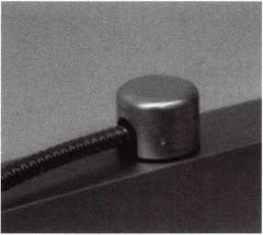

Standard 18”  
length. Can be  
ordered in cus-  
tom lengths

Plastic base stops  
shorts and pro-  
tects wires

Screwless base and cap means you drill two 1/2 inch diameter holes, pop the base into the hole, wire your system and snap on your covers. Simple as 1, 2, 3.

**Here’s the best part We are giving away a**

FREE SAMPLE TO THE FIRST 1 OO CALLERS WHO MEN-  
TION THIS ADD. A $14.40 WHOLESALE PRICE VALUE.

CALL TODAY, IT’S FREE!!

1-800-500-1449

Marray *enterprises, inc.*

At Marray, we’re not just modifiers, we’re Master Hardware Modifiers™  
1128 Walsh Ave., Santa Clara, CA 95050. [www.marray.com](http://www.marray.com)

June 2001

Keynotes 39

Keynotes

■ EMPLOYMENT

Experienced Locksmith Wanted

Live, work, and enjoy Florida’s east coast  
in beautiful Brevard, Co. Must be  
able to run after hour calls. Top salary and

or commission. Call  
**1-888-752-7233**

Experienced Security Te<

Needed

Growing, established coifittercial lock  
company with annual spies exceeding $1  
million seeking e3^^^tce#sec||fity techlf  
nician. Stocke4^J^tgi^de#^ithpl^j^^  
tory, key machines and tools. Applicants  
must have knowledge of commercial lock-  
smithing, including extensive master key  
systems (Medeco/^fst, Schlage, Sargent,  
etc.). Architectural KSte^ware installations,  
including locks, hing^ closers, exit  
devices, continuous hing^^nd hollow  
metal door replacements. Nol|lfpmotive,  
no lockouts, no 24-hr. service. Ifl^Jcends

h: free

1 Ce*

Awesome opportunity for self-motivated

hardworking individuals. Salary commen- ^  
surate with experience. Paid holidays,  
vacation, medical and dental. Retirement  
plan.

Contact:

Redford Lock Company, Inc.

26515 Grand River Ave.

Redford, MI 48240  
Phone 313/535-0400  
Pax 3131535-0559  
e-mail [redfordlock@aol.com](mailto:redfordlock@aol.com)

Experienced Technician Needed

Mid-sized company in sunny California  
(by the beach) seeking a person with a pos-  
itive attitude and a friendly smile. We  
offer paid vacations, paid holidays, med-  
ical and dental insurance, a SEP-IRA pro-  
gram, company provided vehicle, tools  
(except hand tools). We cater mainly to  
the commercial customer with very little  
automotive. On call is NOT mandatory.  
Access Control and safe knowledge is pre-  
ferred but not required.

Contact: Paul

(lltk

Phone: 83023-5415  
fax: 83&f#-5487  
e-***maiha***asafe @vahoo. com

ckmith Wanted

Large lock shop in the Palm Springs area  
of California is looking for an experienced  
locksmith for field work. Must be profi-  
cient in master keying, safety deposit  
boxes and working knowledge of safes.  
Salary plus commission. Health insurance  
benefits and 401(k) plan.

Please fax resume to: 760/779-1811 or call  
760/346-5214.

Building Maintenance Worker III /  
Locksmith, Physical Plant

Under broad supervision, the incumbent is  
responsible for performing maintenance  
improvements, installations and repairs for  
the buildings at the Lowell Campus.  
Primary emphasis will be on locksmith  
duties, door hardware and controlled  
access, as well as supporting the depart-  
ment with interior signage and other  
building trades. The position requires a  
valid Colorado driver's license, license and  
fepndable locksmith credentials and four  
progressive experience in lock and  
contfiihfd access trade. Also, a GED or  
High Sc8|pl diploma needed.

Regis Univi||jty Offers an excellent bene-  
fits package full-time employees  
including lOO^ ^yition for employee,  
spouse and dependefiif||EOE  
E-mail resumes to resumes W^gis. edu or fax to

303-964-5498

Experienced Locksmiths Watted

Do you love the trade of Locksmil^^?  
Are you hard working and self motivaed?  
If you are, we are the company for you. A  
growing locksmith company in California  
are looking for tech that work with auto-  
motive, commerical and resdential.  
Looking for tech that has a min. of 2 yrs.  
of exp. We offer full benefit package,paid  
vacations and bounus pay biweekly.  
Trucks and tools are provided and after a  
year of service stock options are avaliable.

Clean driving record and Bondable is a must. High salary is payed to top techni­cians, average 50K to 70K. Take pride in where you work and come aboard bn a winning team **Locksmith Central 15934 Hesperian Bird**\* %

Suite 264 **t**

San Lorenzo, Ca 94580 Voice: 1.888.81***.Cocks F***ax:(510)317.6860 <mailto:Lcentral@msn.com>

Wanted:Experienced Technicians

Lock into your future now! If you are an experienced, intelligent technician, and desire a secure future, come join our team. We are a full servie commercial/ residen­tial security service (locks, keys, safes, cctv, access control, door related hard­ware). We offer: large sign on bonus, top wages, company vehicle, 40IK, paid vaca­tion, paid holidays, health benefits, new uniforms, cross-training, and JOB SATIS­FACTION. We are looking for the best techs who ae ready to be treated and com­pensated as professionals. Contact:

Bass Security Services, Inc.

(216) 755-1200 Ext:128

(216) 755-1220 fax

e-maill rmesnick @bass-security, com

Experienced Service Technicians Needed

Due to continued growth, we are looking for locksmiths, door operator technicians and low voltage technicians. Our company has been in business since 1880 and is located in the beautiful Pacific Northwest. Argens Inc. is a multidimensional compa­ny. We target commercial and industrial accounts. Our company specializes in gen­eral locksmithing, electronic security (card access & CCTV) and door servicing. We are an employee driven company with excellent pay, benefits, sales incentives, and can offer advancement as our growth continues. Send resume to:

Steve Templeton Argens Incorporated 84 S. Main Street

Seattle, WA 98104

Ilk

***Keynotes***

June 2001



Illlil

(2(M 623-2662 (26§l 622-3056 fax \.argens.com

Service Technician **Wanted**

Locjttmith service technician needed at fas«aced growing firm. Looking for great pa^p>ositive work environment and full beifpts package? Fax resume to: **MriMchmidt**

Prevention Systems Inc.

22805 Savi Ranch Pktvy #B Linda, CA 92887 *am 27$-(m2*

VNTED TO BUY/SELL >ale

tis clipper #15 guns, 1 setup for 47 jfe cuts, 1 special case, holds 39 cams, |arriages, have 46 cams, 75 carriages 3. Also have Reed Code Book #1-14, Please contact me at Masons Locks

fax 371270, Key Largo, FL, 33037i

|  |  |  |
| --- | --- | --- |
| or J | §P05-451-0195 |  |
| or % | ^86-322-4004 |  |
| Twc | (Way Radio System For |  |
| Us! | f| 800 MHz trunked two j | |Sif]radio |
| syfi | Ifn with base unit and 36 h | pd held |
|  | ij with chargers, batteri^ff | hd cases. |
| Fo| | j§iore information cheJMBfc | our web- |
| sitej | 1| -iSif |  |
| $4§ | fjO.OO or Best offer |  |
| Litk | wty Lock and SafUQ/f |  |
| (7% | 1871-5397 |§(f  tv. lihertylock.c^Uf |  |

ES FOR SALE

lliijtiradise!

yin Paradise, California. Well

id shop and van. Turn key opera-

f$50,000 takes it all. Owner wishes

etire. For more information call: (530)

**f2-2998**

Established Locksmith Busines

Established locksmith, bicycle repa|^Kd UPS shipping center in Greenyffl^^IS. Two or more of everything, vralf code machines, duplicators, com^Afs, etc. 1999 gross $225,000. Pri^^ft sell at $75,000. For more info^^^n contact Jerry at (662) 335-907%

Locksmith and Sc^ty Business for Sale

Established 18-yo(3PEi business in a very nice business a^^sort area of western Wisconsin. **^KKbss** and real property asking pric^^^OK. Business is located on main IgjgM&ith two bedroom apts. On second jjjjjBg. Apartment income over $ 1 OK **i^^fe**ar.The current owner will stay with Ijijimyer for up to one year to train bu**gj^P**id help expand the business. **C^fflarry Baker at 8001966-2913.**

jsiness For Sale

Tell established locksmith and safe com­pany in sunny Santa Cruz, California. Many commercial accounts. Business has been in the same location for 41 years. Two+ years left on lease. Two fully equipped mobile units. Must sell due to health.

For more information, call 831/438- 2050. Serious inquiries only, please.

Business for Sale

Successful locksmith business in northern California. Two offices. One in Eureka, the other in McKinleyville. Largest volume in the area. Time to retire. Gross volume last year was almost $300K. Includes latest equipment, all fixtures, all tools and three vehicles. $199,000.

Call Bill Davidson, 707/441-1800.

Business for Sale

We are a busy, well-established company located in suburban New Jersey. We have many commercial accounts in addition to residential work and store sales. We offer complete locksmith services as well as CCTV, access control systems and bur

Classified advertising space is provided free of and fbr;;:fi!Pfa|;

B|Mi|^ij^**M^^B**:!l]^feimum for ncii'in^®

bets. Classified ids may be used to advertise used merchandise and overstocked items for sale, “wanted to buy” items, business oppor- tunities, employment opportunities/posi­tions wanted and the like. Members or non­members wishing to advertise services or new merchandise for sale may purchase a “Commercial Classified Ad,” for a fee of $1.30 per word, with a minimum of $40. Each ad will run for two issues. For blind boxes there is a $5 charge to members and non-members. All ads must be submitted in writing to the ALOA office by the fifteenth of the month, two months prior to issue date. Send to Keynotes Classifieds, 3003 Live Oak St., Dallas TX 75204-6186. ALOA reserves the right to refuse any classified advertise­ment that it deems inappropriate according to the stated purpose or the classified adver­tising section.

glar/fire alarm systems. Gross sales were over $340,000 for 2000 with an annual growth since 1994 of over 20 percent. The sale of the business will include stock, office equipment, service van, fixtures, dis­plays and many key machines. The owner can stay on for a period of time to help smooth the transition and to train the new owner. Please, serious inquiries only. Call 973/417-6074 and leave a message or con­tact us by e-mail at lockbizforsale @ aol. com.

June 2001

Keynotes

k-



**MANUFACTURERS**

•A & B Safe Corp.

(800) 253-1267 FAX (856) 863-1208

•Abloy Door Security

(514) 335-9500 FAX (514) 335-0430

•Adams Rite Manufacturing Co.

(909) 632-2300 FAX (562) 699-5094

•Adesco Safe Manufacturing Co.

web: [www.adesco.com](http://www.adesco.com) (800) 821-6803 FAX (562) 408-6427

•Adrian Steel Company

web: [www.adriansteel.com](http://www.adriansteel.com) (800) 677-2726 FAX (517) 265-5834

•Alarm Lock Systems, Inc.

(800) ALA-LOCK (516)789-3383

•American Lock Co.

(708) 534-2000 FAX (708) 534-0531

•American Security Products (AMSEC)

(800) 423-1881 FAX (909)685-9685

•Baldwin Hardware Corp.

(610) 736-4012 FAX (610) 796-4493

•Buddy Products

1 (800) 886-8688 FAX (312) 733-8536

• BWD Automotive

9(334) 874-9001 FAX (334) 874-6011

•COMPX Security Products

864/297-6655 864/297-9987

•Curtis Industries

1(800) 555-5397

•Cygnus Business Media, Inc.

770/886-0800

770/889-7703

•DETEX Corporation

800/729-3839 830/620-6711

•DORMA Architectural Hardware

717/336-3881

717/336-3500

•Don-Jo Manufacturing, Inc.

978/422-3213

978/422-3467

•Doyle Security Products

800/333-6953

612/521-0166

•DSC Group of Companies

(905) 760-3000 ext. 2200 FAX (905) 760-3040

•Door Controls International

(800) 742-3634 FAX (800) 742-0410

•ESP Lock Products, Inc.

(978) 537-6121 FAX (978) 534-9109

•Ewert Wholesale Hardware

800/451 -0200 708-597-0881

•Fairway Supply, Inc.

214/350-0021

214/352-4299

•H.L. Flake Co.

* HES, Inc.

623/582-4626

623/582-4641

•Hardware Agencies, Ltd.

416/462-

•Hongtai Lock Co Ltd.

137-238-1414

208-793-3856

•llco Unican

(252) 446-3321 FAX (252) 446-4702

* Intellikey

(800) 226-0703 FAX (407) 724-0811

•Jet Hardware Mfg. Co

(718) 257-9600 FAX (718) 257-0973

•KABA High Security Locks

(860) 621-3601 FAX (860) 621-9727

•KEY-BAK; Div. of W. Coast Chain Mfg.

(909) 923-7800 FAX (909) 923-0024

•Knaack Manufacturing Co.

(800) 456-7865 FAX (815) 459-9097

•LAB Security

(800) 243-8242 FAX (203) 583-7838

•LCN Closers (Division of Ingersol)

(815) 875-3311 FAX (815) 875-3222

•La Gard, Inc.

(310) 325-5670 FAX (310)325-5615

•Lucky Line Products

(619) 549-6699 FAX (619) 549-0949

* M.A.G. Engineering & Mfg. Inc.

(714) 891-5100 FAX (714) 892-6845

•MARKS USA

(516) 225-5400 FAX (516) 225-6136

•MARRAY ENTERPRISES

(408) 970-0213; FAX (408) 970-8767

•Master Lock Company

(414) 444-2800 FAX (414) 449-3114

* Medeco Security Locks

(540) 380-5000 FAX (540) 380-5010

•Meilink Safe Company

(800) 634-5465 FAX (800) 896-6606

•MMD Inc.

602/453-3169

602/438-1690

•MCS Communication Systems

865/428-3611 865/453-4136

•Massglass & Door Service

888/742-8837

818/991-5742

•Monaco Lock Co.

800/526-6094

800/845-5625

•ROFU International Corp.

(800) 255-7638 FAX (253) 922-1728

•Rutherford Controls Int'l. Corp.

757/427-1230 757/427-9549

•STRATTEC Security Corp.

(414) 247-3333 FAX (414) 247-3329

•Sargent & Greenleaf, Inc.

(606) 885-9411 FAX (606) 887-2057

•Schlage Lock Co.

(800) 847-1864 FAX (800) 452-0663

•Schwab Corporation

(765) 447-9470 FAX (765) 447-8278

Keynotes

June 2001

For more complete information visit our Web site at aloa.org

•Securitron Magna lock Corp.

5(800) 624-5625 FAX (702) 355-5636

• Security Door Controls

(805) 494-0622 FAX (800) 959-4732

•Security Solutions

(405) 376-1600 FAX (405) 376-6870

•Sentry Group

(716) 381-4900 FAX (716) 381-8559

•Somerset Security Products

800/881-5206

800/206-9949

•Sully Tools Inc.

(703) 689-3416 FAX (703) 787-0869

•Sun-IL Gum Go

823-194-59300

823-194-59400

•Taymor Industries, Inc.

(800) 388-9887 FAX (800) 288-8133

•The National Locksmith

630/837-2044

630/837-1210

•Trine Products Corporation

(718) 829-4796 FAX (718) 792-9127

•Videx, Inc.

(541)758-0521 FAX (541) 752-5285

•W-Lok Corporation

(616) 355-4015 FAX (616) 355-4295

•Yale Security Inc.

(800) 438-1951 FAX (800) 338-0965

**DISTRIBUTORS**

•Accredited Lock Supply Co.

(800) 652-2835 FAX (201) 865-5031

•Ace Lock & Security Supply Co.

(800) ACE-LOCK (800) ACE-FAX4

•ADI

(516) 692-1000 FAX (516) 692-3457

•Andrews Wholesale Lock Supply

(717) 272-7422 FAX (717) 274-8679

•Boyle & Chase Inc.

(800) 325-2530 FAX (800) 205-3500

•Clark Security Products, Inc.

(800) 854-2088 FAX (619) 974-5284

•Cook's Building Specialties

(505) 883-5701 FAX (505) 883-5704

•Dire's Lock & Key Co.

(303) 294-0176 FAX (303) 294-0198

•Direct Security Supply, Inc.

(800) 252-5757 FAX (800) 452-8600

* Doyle Security Products

(800) 333-6953 FAX (612) 521-0166

•Dugmore & Duncan Inc.

(888) 384-6673 FAX (888) 329-3846

•E. L. Reinhardt Co., Inc.

(800) 328-1311 FAX (612) 481-0166

•Foley-Belsaw Company

(800) 821-3452 FAX (816) 483-5010

•Fried Brothers, Inc.

(800) 523-2924 FAX (800) 541-3489

•HS&S Wholesale Distributors

1(800) 521-2202 FAX (313) 342-7580

•Hans Johnsen Company

(214) 879-1550 FAX (214) 879-1530

•Howard Keys

(704) 598-2291 FAX (704) 598-9110

•IDN, Inc.

(817) 421-5470 FAX (817) 421-5468

•Intermountain Lock & Supply Co

(800) 453-5386 FAX (801) 485-7205

•Jo-Van Distributors Inc.

(416)752-7249 FAX (416) 752-3845

* Lockmasters, Inc.

(800) 654-0637 FAX (859) 885-7093

•Locks Company

(800) 288-0801 FAX (305) 949-3619

•The Locksmith Store Inc.

(847) 364-5111 FAX (847) 364-5125

•M. Zion Company

(212) 349-8677 FAX (212) 964-0495

* McDonald-DASH Locksmith Supply

(800) 238-7541 FAX (901) 366-0005

•McManus Locksmith Supply, Inc.

(702) 333-9112 FAX (704) 332-8664

•MARRAY ENTERPRISES

(408) 970-0213 FAX (408) 970-8767

•Securite.com

(800) 241-3930 FAX (619) 974-5269

•Omaha Wholesale Hardware

(800) 238-4566

•Sentry Security Fasteners

(309) 693-2800 FAX (309) 693-2872

•Southern Lock and Supply Co.

(800) 237-2875 FAX: (800) 447-2299

* Stone & Berg Wholesale

(800) 225-7405 FAX (800) 535-5625

•Strauss Safe & Lock Company

(515) 288-9571 FAX: (515)288-9752

•Taylor Securtiy & Lock Co.

(301) 948-7670 FAX (301) 948-1029

•Timemaster, Inc.

(785) 232-8705 FAX (800) 798-8463

•Top Notch Distributors, Inc.

(800) 722-4210 FAX (800) 248-3620

•U.S. Lock Corporation

(800) 925-5000 FAX (800) 338-5625

•Webster Safe & Lock Company, Inc.

(901)332-2911 FAX (901) 332-2878

**SERVICE**

•Allstate Insurance Company

(847) 402-8196 FAX (847) 326-7509

| 43

L_

June 2001

Keynotes

About the Authors

Bob Arthur; RL

Ad Index

ALOA 2001

*is an ALOA certified instructor who taught at the ALOA convention and at regional conventions in the United States. He owns and oper­ates Arthur Lock & Key in Phoenix, AZ.*

Member Benefits

IFC

1

***Claire Cohen, CML***

*hthe second woman to become a CML, has been in locksmithing since 1977 and has been writing articles for Keynotes since 1987. She is alos a contributing editor for Keynotes.*

***Sal Dulcamaro, CML***

*H*

*has been in the locksmith business for over 26 years.*

*He is the president of All Pro Security, Inc. in  
Michigan and has been an ALOA member for 19  
years. A past president of the Locksmith Security  
Association of Michigan. Sal currently serves as  
editor of the association newsletter. He was named*

*“Keynotes Author of the Year” for 1996 and 1997. He is also a  
contributing edito for Keynotes.*

*Find Sal on the internet at: http:!lhome.earthlink.net!-lockwriter.*

***A.J. Hoffman***

*is a recognized authority on cylinders and keying.  
He has served several terms as a membert-at-large  
to the ALOA Board. In 1988, he was inducted  
into the Locksmith Ledger Security Hall of Fame.  
In 1992, he received the coveted Philadelphia  
Award. He is currently the Product Manager for  
Cylinders and Key Systems for both Schlage and*

*Falcon Lock, divisions of Ingersoil Rand. He has held similar posi-  
tions with Kaba and Corbin Russwin.*

V

H

***Greg Perry, CML, CPS***

*has been in the locksmith industry for 18 years. He's spend half of that time as a field technician for Security Engineering in Ridgecrest, Calif. Greg is also a past president of the Desert Counties Chapter of the California Locksmiths Association.*

***Warren Schimizzi***

*Warren Schimizzi is a training specialist for Medeco High Security Locks in Salem, Virginia. He is an ALOA Ace Certified Instructor.*

SIAM Insight 5

President's Club 7

ABUS 9

KSP 11

LockMaster 13

Speedy-Pik 23

Fax on Demand 37

MasterLink 39

Marray 39

Fundamentals of Master Keying IBC

Hickok BC

**441**

Keynotes

June 2001

Get the best master keying textbook

around, written by one of the most

well- known locksmith instructors

in the profession. Just $44.00

[including shipping and handling],

Fundamentals of Master Keying

covers system structure and record

keeping; basic mechanical and

arithmetic concepts; and how to

write a system

*An Introduction to Split Pin Master Keying*

To order, write or FAX:

Associated Locksmiths of America, Inc.; 3003 Live

Oak Street Dallas TX 75204 FAX (214) 827-1810

Credit card orders: Phone (214) 827-1701

**Jerome V. Andrews, CML**

m gib

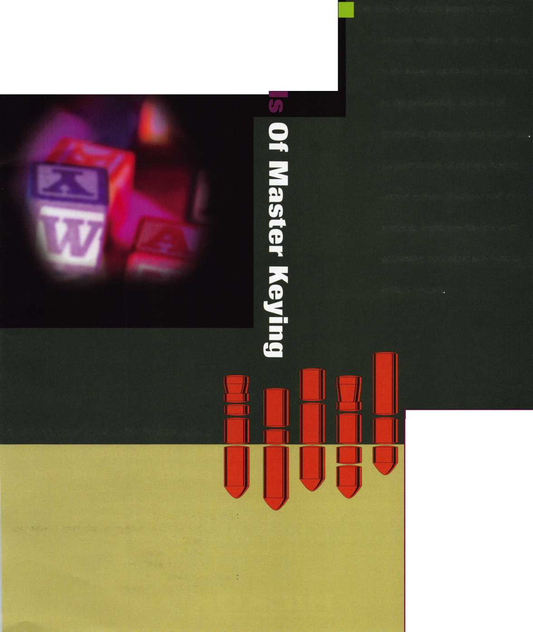

80°'8 e up°at

;xa\u£

**" Jump ahead of the competition at warp speed and see your profits soar.**

|  |  |
| --- | --- |
| H 1 . |  |
|  |  |
|  | ' |

**Hickok’s New Generation STAR transports you with the factory tool for programming keys to  
Ford-Lincoln-Mercury and Mazda vehicles with passive anti theft systems (PATS).**

**Program vehicle keys through Model Year 2001 with Hickok’s NGS Model 800-8LA-$1995 ^ Update your existing software-the 2001 Complete New Model Ford Software Update Model 80LA-$895**

**800**/**342-5080**

**HICKOK**

**INCORPORATED**

ivupup.hickok-inc.

cot

